BLM GUIDELINES
FOR IMPLEMENTING
GREATER SAGE-GROUSE HABITAT OBJECTIVES

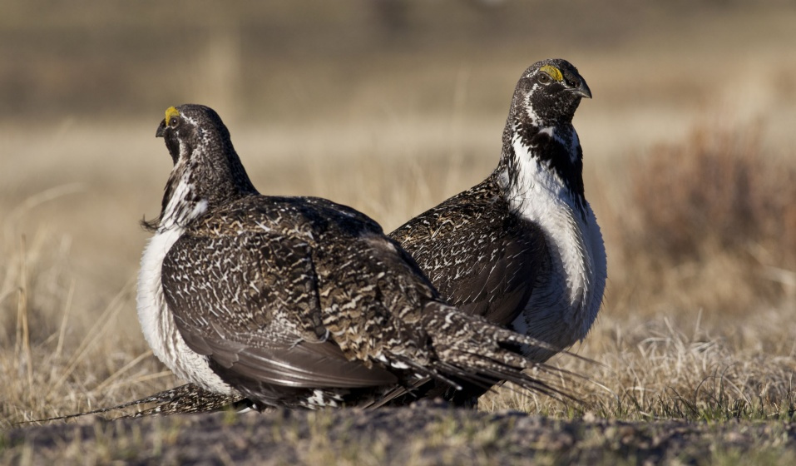

Issued by
the BLM Division of Wildlife, Aquatics and Environmental Protection
January 2020

Table of Contents
PURPOSE 1
BACKGROUND 1
GUIDELINES 2
Appropriate Uses of the Habitat Objectives Table 2
Inappropriate Uses of the Habitat Objectives Table 2
Using Indicators and/or Values Other than Those in the Habitat Objectives Table 3
Integrating the HAF Site-Scale Assessment into LHS Evaluations 4
CONTACTS 6

PURPOSE
These Bureau of Land Management (BLM) guidelines (herein referred to as Habitat Objectives Guidelines) serve three primary purposes:
- To comply with, and implement, Secretarial Order 3353, “Greater Sage-Grouse Conservation and Cooperation with Western States” (June 7, 2017), by clarifying issues related to BLM sage-grouse land use plans and policies
- To implement BLM MS-6500, Wildlife and Fisheries Management, according to which the responsibilities of the chief of the BLM Division of Wildlife, Aquatics and Environmental Protection (once known as the BLM Division of Wildlife and Fisheries) include development of fish and wildlife management policy, procedures, and technical guidance (6500.04.C.1.)
- To clarify and update WO IM 2018-025, Implementation of the Habitat Objectives Table from the 2015 [and/or 2019] Greater Sage-Grouse Approved Resource Management Plans and Amendments, which instructs offices on how to proceed when they consider modifying or adding indicators and/or values to the current Habitat Objectives Table of Greater Sage-Grouse (GRSG) Plans unless the applicable GRSG Plan already contains such a process

By providing these Habitat Objectives Guidelines (which are based on Secretarial Order 3353, BLM MS-6500, 43 CFR 4180.1, and existing policy), the BLM Division of Wildlife, Aquatics and Environmental Protection is promoting consistency among BLM offices when using habitat objectives for Greater Sage-Grouse, including the Bi-State Distinct Population Segment (sage-grouse). These guidelines recommend use of the best available science, review appropriate application of the Habitat Objectives Table, and explain the relationship of the Habitat Objectives Table to land health standards (LHS) evaluations.

BACKGROUND
The Habitat Objectives Table identifies vegetation indicators important to sage-grouse site selection within seasonal use areas, nest success, and brood-rearing success. The vegetation values shown in the Habitat Objectives Table are desired conditions based on site selection studies for sage-grouse within the planning area. Collectively, the vegetation indicators for sagebrush (cover, height, and shape), perennial grasses, and perennial forbs (cover, height, and/or availability) represent the desired vegetation components for seasonal habitats. All indicators and values are supported by the best available science on sage-grouse site selection studies at the time of publication.
Not all locations within a given seasonal habitat area will be able to achieve the indicator values in the Habitat Objectives Table, due to the inherent variation in vegetation communities and ecological site potential. Additionally, not all locations within a given seasonal habitat area will be able to achieve the indicator values in the Habitat Objectives Table at all times, owing to environmental factors such as drought or fire. Point-in-time measurements should document environmental factors (e.g., weather patterns, localized drought) on the suitability forms from the Sage-Grouse Habitat Assessment Framework: A Multiscale Assessment Tool, Technical Reference 6710-1 (HAF), because environmental factors can influence a site’s ability to achieve the indicator values in the Habitat Objectives Table and because they will be considered during LHS evaluations.

GUIDELINES
These Habitat Objectives Guidelines supplement the 2018 policy set forth in WO IM 2018-025 (effective until 9/30/2021).

BLM state offices (SOs) must follow the steps described in the policy when evaluating, in an interdisciplinary setting, if there are data and science to use as alternatives to the indicators and/or values (desired conditions) found in the Habitat Objectives Table unless the applicable GRSG Plan outlines an alternative process (italicized text conforms the policy with certain 2019 sage-grouse plan amendments).

Appropriate Uses of the Habitat Objectives Table
BLM offices use the Habitat Objectives Table as described below (see also Figure 1):
- BLM offices must use the Habitat Objectives Table indicators and desired conditions (values) found in their GRSG Plan as suitable values when assessing site-scale or Fourth Order suitability of GRSG habitat (refer to the HAF).
- BLM offices should also use the Habitat Objectives Table indicators and values as a component of GRSG Plan effectiveness evaluations, to detect change from baseline vegetation conditions (the conditions at the onset of a monitoring program), and to quantify the trend of the indicator values.
- BLM offices may also use appropriate indicators and values from the Habitat Objectives Table to develop measurable objectives for vegetation treatments and management actions within sage-grouse habitat management areas.

Inappropriate Uses of the Habitat Objectives Table
To avoid inappropriate uses of the Habitat Objectives Table, BLM offices comply with the following guidelines regarding use (Note: this is not a comprehensive list of uses):
- BLM offices must not use the indicator value(s) as default without considering the ecological site potential and relevant local information where measurements were taken.
- BLM offices must not use a single measured indicator value to determine site-scale sage-grouse habitat suitability, unless sagebrush is absent or limiting. In that instance, a single indicator related to sagebrush may dictate site-scale suitability.
- BLM offices must not use an indicator(s) measured only one time (i.e., no trend context) as the only criterion to modify an authorized use, such as grazing authorizations (BLM H-4180-1, Rangeland Health Standards), or to take the place of a causal factor determination.

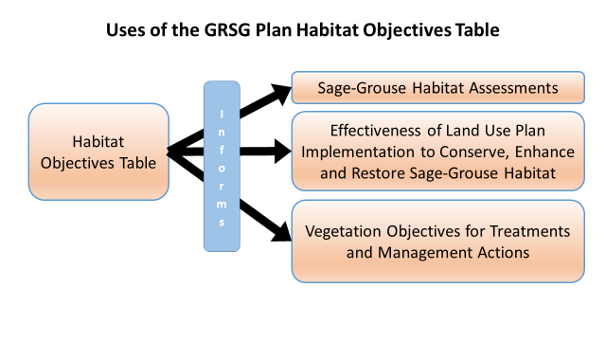
Figure 1. Three Primary Uses of the Habitat Objectives Table

Using Indicators and/or Values Other than Those in the Habitat Objectives Table
Using indicators and/or values other than those in the Habitat Objectives Table may be appropriate where, for example, local data and best available science indicate that sage-grouse select vegetation structure and composition in seasonal habitats that are not characterized by the indicators and/or values in the Habitat Objectives Table. Data and science must be supported by
repeatable and documented methods and any pertinent information related to site-scale habitat selection, such as the season of data collection. SOs and field offices (FOs) must follow the process described below when considering modifying or adding to the indicators and/or values found in the current Habitat Objectives Table unless the applicable GRSG Plan contains a process for modifying the indicators and/or values in the Habitat Objectives Table (in which case the BLM must use the plan’s process).
Step 1: Staff evaluate the data and science against the following criteria:
- Indicators and/or values in the new science sufficiently describe habitat selection and the potential of the ecological sites.
- The new science must be peer-reviewed (e.g., journals, theses, dissertations) and available to the public.
- A change in the indicator value must be detectable (so that trend can be monitored over time).
- The indicators and/or values have been reviewed and accepted by the state wildlife agency, if the agency elects to participate.
Step 2: SOs must adjust the GRSG Plan to add or modify the indicators and/or values before using the new indicators and/or values for the applicable seasonal use area(s) to complete HAF Habitat Suitability Assessment Reports, to perform GRSG Plan effectiveness evaluations, or to establish objectives for vegetation treatments and management actions. Whenever an alternative indicator and/or value is used, the use must be documented, along with the rationale(s) and the scientific references supporting the use.

Integrating the HAF Site-Scale Assessment into LHS Evaluations
The process for land health assessments and LHS evaluations has not changed. Standards for rangeland health must be achieved, maintained, or significant progress toward achievement must be shown. Current guidance is found in BLM H-4180-1, Rangeland Health Standards. When the BLM applies land health standards to land health assessments, such standards are applied regardless of land use or activity. If rangelands are meeting all applicable land health standards, adjustments to uses are typically unnecessary. If the BLM determines that rangelands are not meeting land health standards, then the BLM determines the causal factors and implements appropriate management actions to ensure the area is making significant progress toward achieving the standards. When authorizing these appropriate management actions, the BLM should implement a monitoring plan to determine if the actions are accomplishing the desired result.
An important use of these habitat objectives is to support the assessment of the wildlife/special status species (SSS) land health standards. The suite of indicators within the Habitat Objectives Table informs the site-scale suitability of seasonal habitats. These suitability ratings are then used as the primary line of evidence when evaluating the sage-grouse portions of the wildlife/SSS LHS evaluations (Figure 2). Achieving land health standards for sage-grouse habitat supports the goal of healthy, intact sagebrush systems while providing for the long-term sustainability of rangelands for livestock grazing, wildlife habitats, and other uses.
Information captured during site-scale assessments, particularly ecological site potential and an area’s ability to meet the habitat objectives, can help in estimating whether or not the values for the indicators in the Habitat Objectives Table are achievable for a given area. The ecological potential of a site is informed by: an appropriate Ecological Site Description (ESD) about land units that share similar capabilities to respond to management activities or disturbance; associated state and transition models; and other pertinent data used to complete a Reference Sheet, as described in Interpreting Indicators of Rangeland Health, BLM Technical Reference 1734-6 (IIRH). If an appropriate ESD is not available, staff use IIRH to identify an existing ESD that is comparable in terms of soil, moisture, aspect, and slope of the site in question. If no comparable ESD is available, staff follow the process described in IIRH for developing a Reference Sheet absent an ESD. More information on ESDs is available at: https://www.nrcs.usda.gov/wps/portal/nrcs/main/national/technical/ecoscience/desc/.

Figure 2. Flowchart for Incorporating the Sage-Grouse Habitat Assessment Framework into Land Health Standards Evaluations 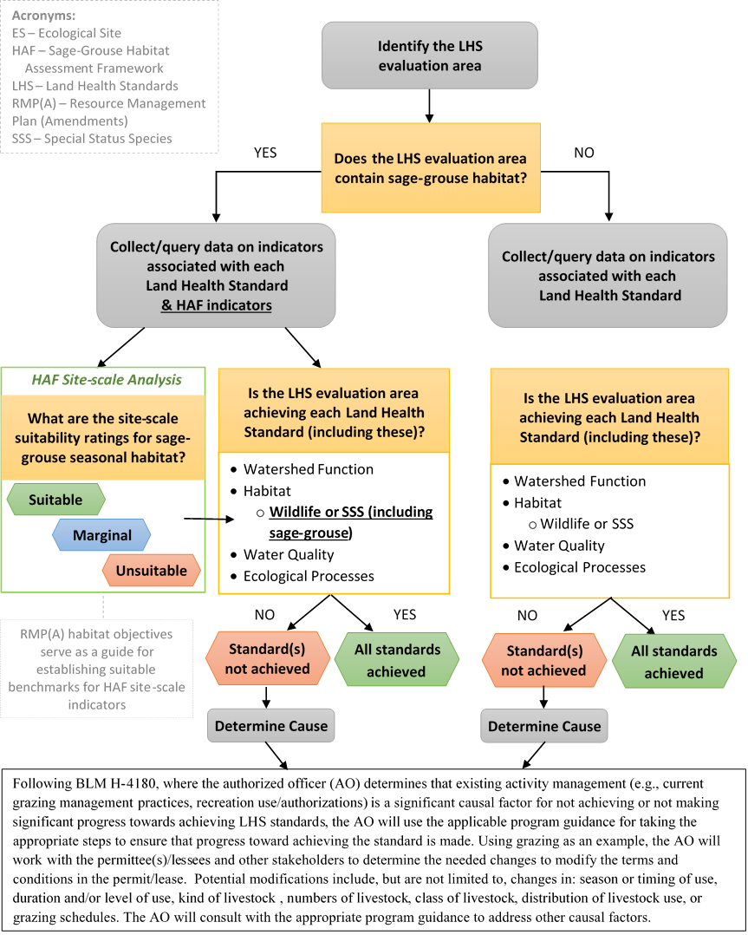

CONTACTS
BLM staff should use the table below to direct their questions or concerns to the biologist or implementation coordinator at the state office or national office level.
BLM Sage-Grouse Conservation Contacts (FY19)

Office | Implementation Coordinators | Sage-Grouse Biologists
Washington Office  20 M Street SE  Washington, DC 20003 | Vicki Herren  National Sage-Grouse Coordinator  vherren@blm.gov  (202) 912-7235 | Vicki Herren  National Sage-Grouse Coordinator  vherren@blm.gov  (202) 912-7235  Megan McLachlan  mmclachlan@blm.gov  (303) 236-5427
California  (CA-930)  602 Cressler Street  Cedarville, CA 96104 | Arlene Kosic  akosic@blm.gov  (530) 279-2726 | Arlene Kosic  akosic@blm.gov  (530) 279-2726
Colorado  (CO-930)  2850 Youngfield Street  Lakewood, CO 80125 | Leah Waldner  lwaldner@blm.gov  (801) 539-4148 | Robin Sell  rsell@blm.gov  (303) 239-3723
Idaho  (ID-931)  1387 S Vinnell Way  Boise, ID 83709 | Jonathan Beck  jmbeck@blm.gov  (208) 373-3841 | Ethan Ellsworth  eellsworth@blm.gov  (208) 373-4045  Paul Makela  pmakela@blm.gov  (208) 373-3809
Montana/Dakotas  (MT-930)  5001 Southgate Drive  Billings, MT 59101-4669 | John Carlson  jccarlso@blm.gov  (406) 896-5024 | John Carlson  jccarlso@blm.gov  (406) 896-5024
Nevada  (NV-930)  1340 Financial Boulevard  Reno, NV 89502 | Matthew Magaletti  mmagalet@blm.gov  (775) 861-6472 | Quin Young  qyoung@blm.gov  (775) 861-6475
Oregon/Washington  (OR-930)  1220 SW 3rd Avenue  Portland, OR 97204 | Molly Anthony  manthony@blm.gov  (503) 808-6052 | Glenn Frederick  gfrederick@blm.gov  (503) 808-6379
Utah  (UT-933)  440 W 200 S, Suite 500  Salt Lake City, UT 84125 | Mellissa Wood  mrwood@blm.gov  (801) 539-4068 | Jared Reese  jreese@blm.gov  (801) 539-4058
Wyoming  (WY-0930)  5353 Yellowstone Road  Cheyenne, WY 82003 | Jennifer Marzluf  jmarzluf@blm.gov  (307) 775-6090 | Darren Long  dlong@blm.gov  (307) 775-6111
National Operations Center  Denver Federal Center  Building 50  Denver, CO 80225-0047 | N/A | Anthony Titolo  atitolo@blm.gov  (303) 236-0446
National Training Center  9828 N 31st Avenue  Phoenix, AZ 85051-2517 | N/A | Lori Young  lyoung@blm.gov  (602) 906-5640

