AIM 2015 End of Season Sample Point Reporting

- SeasonEnd2015_XXXX – This is the plot location reporting requirement for the end of field season 2015. This is a file geodatabase (XXXX will be replaced by the project name) to contain sample design information as well as actual plot locations for the sample plots. It will be completed by the crew lead or project lead at the end of the field season and included in the data provided to the BLM National Operations Center (NOC) at the end of the field season. The location of the points in the Sample Points feature class will be populated by the NOC or the Jornada based on the Sample Design and the Sample Design Database. Fields in this feature class will be completed by the crew lead or project lead (highlighted in yellow below). The Actual Points feature class will contain the locations of the actual plots visited along with the name of the plot provided in the Sample Design and populated by the crew lead or project lead. The Plot Name in both the Sample Points feature class and in the Actual Points feature class should be the same and be the original name given to the point by the person who created the sample design. The location of the plots in the Actual Points feature class should be populated from the plot center GPS points in DIMA.

  - Sample Points (Points)
The Sample Points feature class contains the location of points that were given to the field office by whoever completed the Sample Design for the project. This includes ALL points, both those visited and those rejected, base and oversample. Steps to be taken for this feature class are to populate the Actual Stratum Name, Date Visited, and Rejection Criteria (populate with one of the Target Sampled options in the dropdown) fields for the points that were visited and to populate the Rejection Criteria and Rejection Criteria comments for those points that were not visited (fields to be completed are highlighted in yellow below). If the site was an oversample point, then you can populate the Rejection Criteria with ‘Site Not Sampled’.
Field | Alias | Description | Domain | Field Type | Length
PLOT_NM | Plot ID (Plot Name) | Primary Key. This is the name of the plot given to you by whoever did the sample design. It should be in the format of STRATA_NUM or something similar, this should be the plot name used in your DIMA and the same as Actual Points (below). | NONE | TEXT | 500
ADMIN_ST | Administrative State | The BLM state in which this project took place. | BLM States | TEXT | 100
ADM_UNIT_CD | Administrative Unit Code | The BLM office (field, district, or state) in which this project took place and was managed out of. | BLM Offices | TEXT | 100
DSGN_STRTM_NM | Design Stratum | This is the stratum that the plot was supposed to be in during the design portion. This field should not be changed after the sample design phase. | NONE | TEXT | 100
ACTL_STRTM_NM | Actual Stratum | This is the field in which you note the actual stratum in which the plot was located. It may or may not be the same as design stratum. This should be based on field verification. If you did not visit the plot, leave this field NULL. | NONE | TEXT | 100
PAIRED_PLOT | Paired Plot | You should note if the plot was a paired plot. This field contains a simple Yes/No. | Yes/No | TEXT | 100
DT_VST | Date Visited | If you visited the plot, this is where you should put the date in which you visited the plot. | NONE | DATE
COMMENT | Comments | If you have any comments about the plot, please put them here. | NONE | TEXT | 500
RejCrit | Rejection Criteria | If you visited the plot, then populate this field with one of the Target Sampled (in expected stratum or not in expected stratum) options. If you did not visit the plot then select which rejection criteria was used (Office and Field options). | Terrestrial Rejection Criteria, see Appendix A. | TEXT | 75
RejCritComments | Rejection Criteria Comments | If you have comments regarding the reason for rejecting the plot, populate them here. | NONE | TEXT | 200
ProjectContact | Project Contact Name | This field should contain the Project Lead or main contact name. | NONE | TEXT | 50
ContactInfo | Contact Info (Email, Phone) | This field should contain the contact information – email address and phone number- for the above Project Lead or main contact. | NONE | TEXT | 200
Revisit | Revisit? | Is this plot a revisit plot? | Yes/No | TEXT | 50
OriginalPlotID | Original Plot ID | If this is a revisit plot, this field is to contain the plot ID of the original plot, the plot that you are revisiting. | NONE | TEXT | 50

  - Actual Points (Points)
The actual points feature class should store the location of the plot visited by the field crew. This data should be downloaded from DIMA and populated in this feature class by the crew lead or the project lead at the end of field season (for instructions see Appendix B). One QA/QC step that should be taken for this data is to compare the sample plot location to the actual plot location (a join can be done spatially or through the PLOT ID fields in both feature classes). If the distance between the two plots is high or the plot location looks wrong, the DIMA plot locations should be checked for common errors such as missing numbers, extra numbers, or non-numeric values in the field. If this does not correct the issue, the GPS points collected in a GPS unit should be referenced. The DIMA plot locations should be corrected and then the plot locations should be exported again to this feature class along with
Field | Alias | Description | Domain | Field Type | Length
PLOTID | Plot ID (Plot Name) | Primary Key. This is the name of the plot given to you by whoever did the sample design. It should be in the format of STRATA_NUM or something similar, this should be the plot name used in your DIMA and the same as Sample Points (above). | NONE | TEXT | 500
X_LONG | X (Longtitude) | This should be the actual Longitude of the sampled plot. This should be taken from your DIMA and checked against the Sample Point location. If the distance between the sample plot location and the actual plot location is further than 200 meters, double check with the plot location saved in your GPS. | NONE | INTEGER | LONG
Y_LAT | Y (Latitude) | This should be the actual Latitude of the sampled plot. This should be taken from your DIMA and checked against the Sample Point location. If the distance between the sample plot location and the actual plot location is further than 200 meters, double check with the plot location saved in your GPS. | NONE | INTEGER | LONG
LocSrc | Location Source | This should be the source of the location. The default should be the DIMA, but if you reference a GPS or re-enter the location from a field form, this should be noted in this field. | DIMA/GPS/FFORM/OTHER | TEXT | 50
LocSrcComment | Location Source Comment | This field should contain comments regarding the source of the actual plot location. If you had to reference a GPS or change an alphanumeric in DIMA, this should be where you comment on that. | NONE | TEXT | 500
Moved | Moved? | This is a field to note if the plot was moved and what direction and length the plot was moved. If the movement doesn’t match the domain list, then please describe where and why it was moved in the Moved Comments field. | 50N/50E/50S/50W/100N/100E/100S/100W/Other | TEXT | 50
MovedComment | Moved Comment | This field contains comments on why a plot was moved and where it was moved to. | NONE | TEXT | 200

Appendix A: Rejection Criteria Domain List
DOMAIN | DOMAIN DESCRIPTION
Office - Unsafe to sample | Office Rejection Criteria: Sample point is unsafe to sample.
Office - > 3 miles walking distance | Office Rejection Criteria: Sample point is >3 miles walking distance from the closest point accessible by a vehicle.
Office - Non-BLM land | Office Rejection Criteria: Sample point falls on non-BLM land.
Office - Slope > 50% | Office Rejection Criteria: Slope of sample point exceeds 50%
Office - Access Denied | Office Rejection Criteria: Access to the point was denied: (Information below should be put in Rejection Criteria Comments field)  - Access route unsafe  - Access required passage through non-BLM land, access was denied  - Owner contacted on _______________________.  - Locked gate  - Access denied but visit rescheduled for ___________________________.
Office - Transect crosses boundary | Office Rejection Criteria: (Optional, determined by the monitoring objectives) The sample point transect crosses a boundary between different management units (e.g., in an allotment-scale monitoring project, the sample point intersects two allotments).
Field - Unsafe to sample | Field Rejection Criteria: Sample point is unsafe to sample (e.g., unstable soil surface, cliffs, hazardous wildlife, law enforcement concerns).
Field - >3 miles walking distance | Field Rejection Criteria: Sample point is >3 miles walking distance from the closest point accessible by a vehicle.
Field - Slope > 50% | Field Rejection Criteria: Slope of sample point exceeds 50%.
Field - Access Denied | Field Rejection Criteria: Access to the point was denied: (Information below should be put in Rejection Criteria Comments field)  - Access route unsafe  - Access required passage through non-BLM land, access was denied  - Owner contacted on _______________________  - Locked gate  - Access denied but visit rescheduled for ___________________________
Field - Intersects wetland, riparian, or aquatic feature | Field Rejection Criteria: (Optional, determined by the monitoring objectives) Sample point transect intersects wetland, riparian or aquatic feature.
Field - Intersects Road | Field Rejection Criteria: Sample point transect intersects a road or primitive road.
Target Sampled - in expected stratum | Target was successfully sampled (thus NO rejection) and it was in the expected stratum (Design Stratum and Actual Stratum fields will be the same).
Target Sampled - not in expected stratum | Target was successfully sampled (thus NO rejection) and it was NOT in the expected stratum (Design Stratum and Actual Stratum fields will be different).
Site not sampled | Site was not sampled (this should be used for Over Sample points or points that were not gotten to by field crews, but not actually rejected).
Temporarily Inaccessible | If the site was temporarily inaccessible, then select this option and elaborate in the Reject Criteria Comments field as to the nature of the temporary inaccessibility.
Archeology Site | If evidence of archeology site is found, and the site is rejected for that reason, please select this option.

Appendix B: Downloading GPS coordinates from DIMA
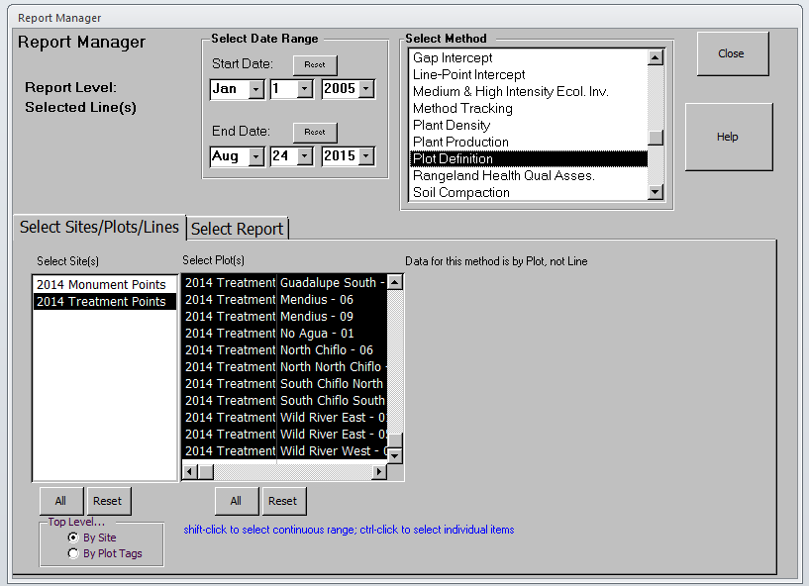
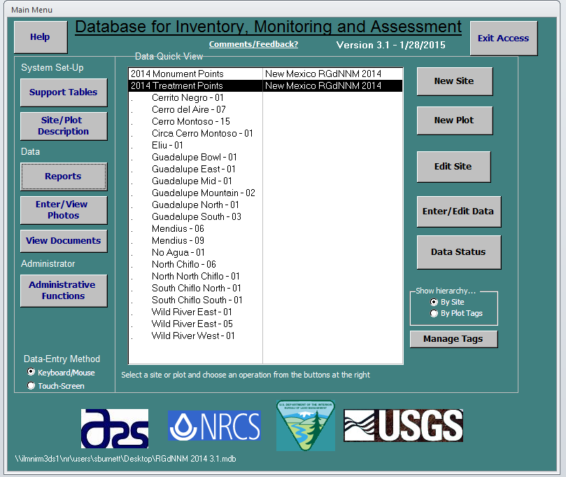
Select ‘Plot Definition’ in the Select Method Listbox, then highlight the desired Sites and Plots in the Select Site(s) and Select Plot(s) List boxes.
Select Report on the Home Screen in DIMA

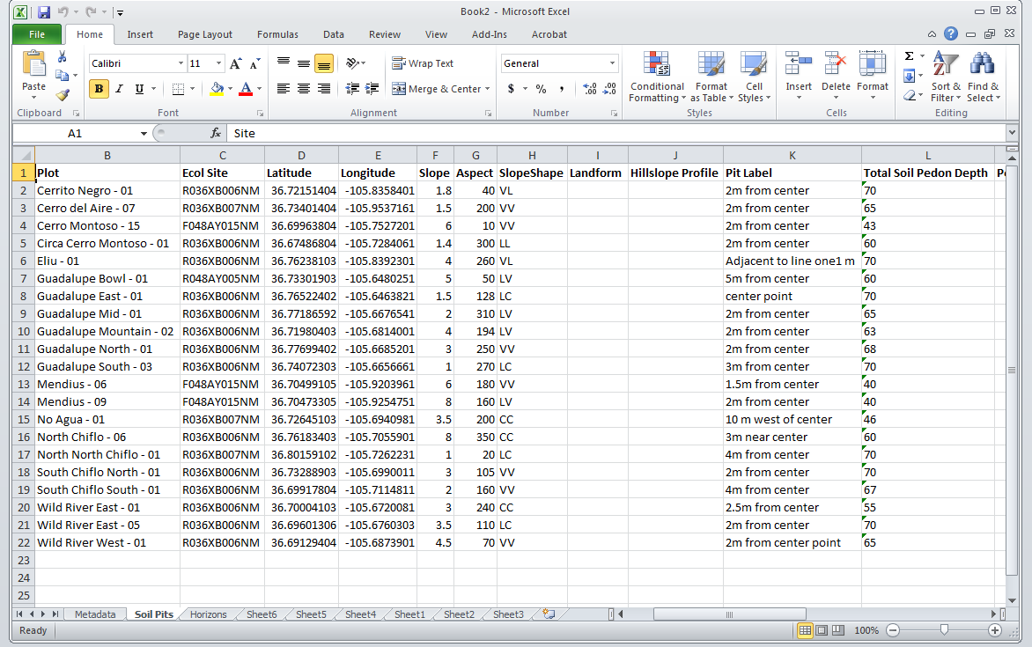
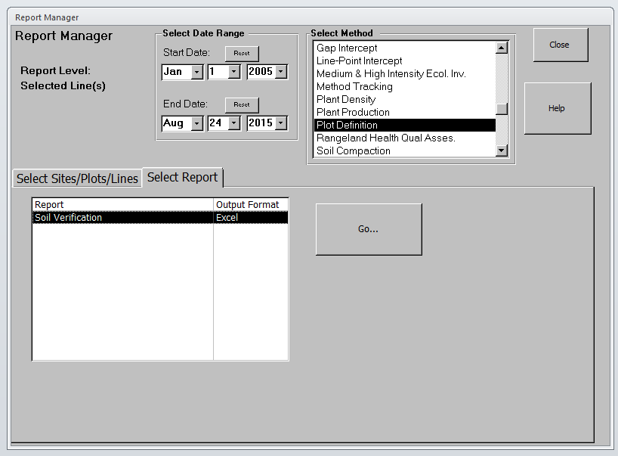
An Excel report will display that has a ‘Soil Pits’ tab. In this tab are a Latitude column and Longitude column that can be loaded into the Actual Points feature class.
Then click on the Select Report Tab and highlight Soil Verification and click the ‘Go…’ button.

