Accessing AIM Data
Instruction Manual

Connecting to AIM Data:
TerrADat: Terrestrial AIM Database
LMF: Landscape Monitoring Framework Database

Created by: BLM National Operations Center
Version 1.2 August 2016

I. Background
TerrADat (Terrestrial AIM Database) houses all terrestrial monitoring data collected for BLM projects using the Assessment, Inventory, and Monitoring (AIM) Strategy. Following field season, project DIMAs (Databases for Inventory, Monitoring, and Assessment) are uploaded into TerrADat.
LMF (Landscape Monitoring Framework Database) houses all terrestrial monitoring data collected broadly across BLM land by NRCS crews using the AIM Strategy for the Landscape Monitoring Framework. Data is transferred annually from the NRCS to the BLM and uploaded into the LMF database.
Both TerrADat and LMF datasets contain the AIM core terrestrial indicators collected using the standard methods. However, due to slight differences in the data capture tools and the way that species were handled, some of the indicators are slightly different. Information on how each indicator was calculated can be found in the metadata of each dataset.
This instruction manual focuses on how to connect to the TerrADat and LMF databases. If you have any feedback about either database or this instruction manual, please fill out this form!

II. Adding TerrADat and LMF data layers to an ArcMap MXD.
A couple of ways to add the AIM Data layers to an ArcMap MXD.
- Add the layers through ArcCatalog in an open ArcMap MXD:
  - Open up a blank MXD in ArcMap
  - Make sure that you have ArcCatalog open in the MXD:
    - Under the ‘Windows’ menu, select ‘Catalog’ 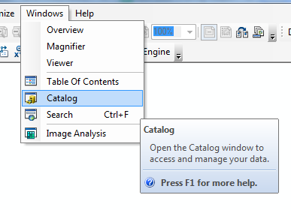
  - Connect to GeoSpatialGateway:
    - Click on the Connect to Folder Icon at the top of ArcCatalog: 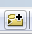
    - Enter \\blm\dfs\loc\EGIS\GeoSpatialGateway in the Connect to Folder pop-up: 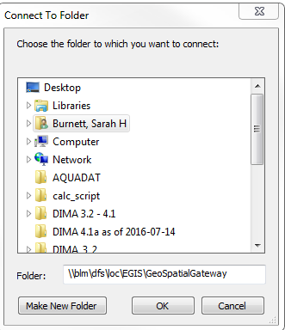
    - Click OK
  - Navigate to AIM Data in GeoSpatialGateway:
    - Open GeoSpatialGateway folder
    - Open Vegetation Folder
    - TerrADat data can be found under the BLM_Natl_AIM_TerrADat folder and LMF data can be found under the BLM_Natl_LandscapeMonitoringFramework folder.
    - Under each folder open the Service_Layer folder. 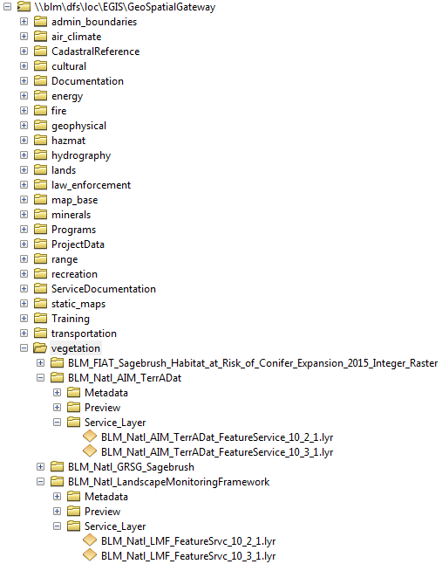
    - Drag and drop each layer file into your MXD (there are 2 layer files in each folder, one for Arc 10.2.1 and one for 10.3.1 – use the layer file that matches your version of Arc).
  - You should then have a map that looks something like this: 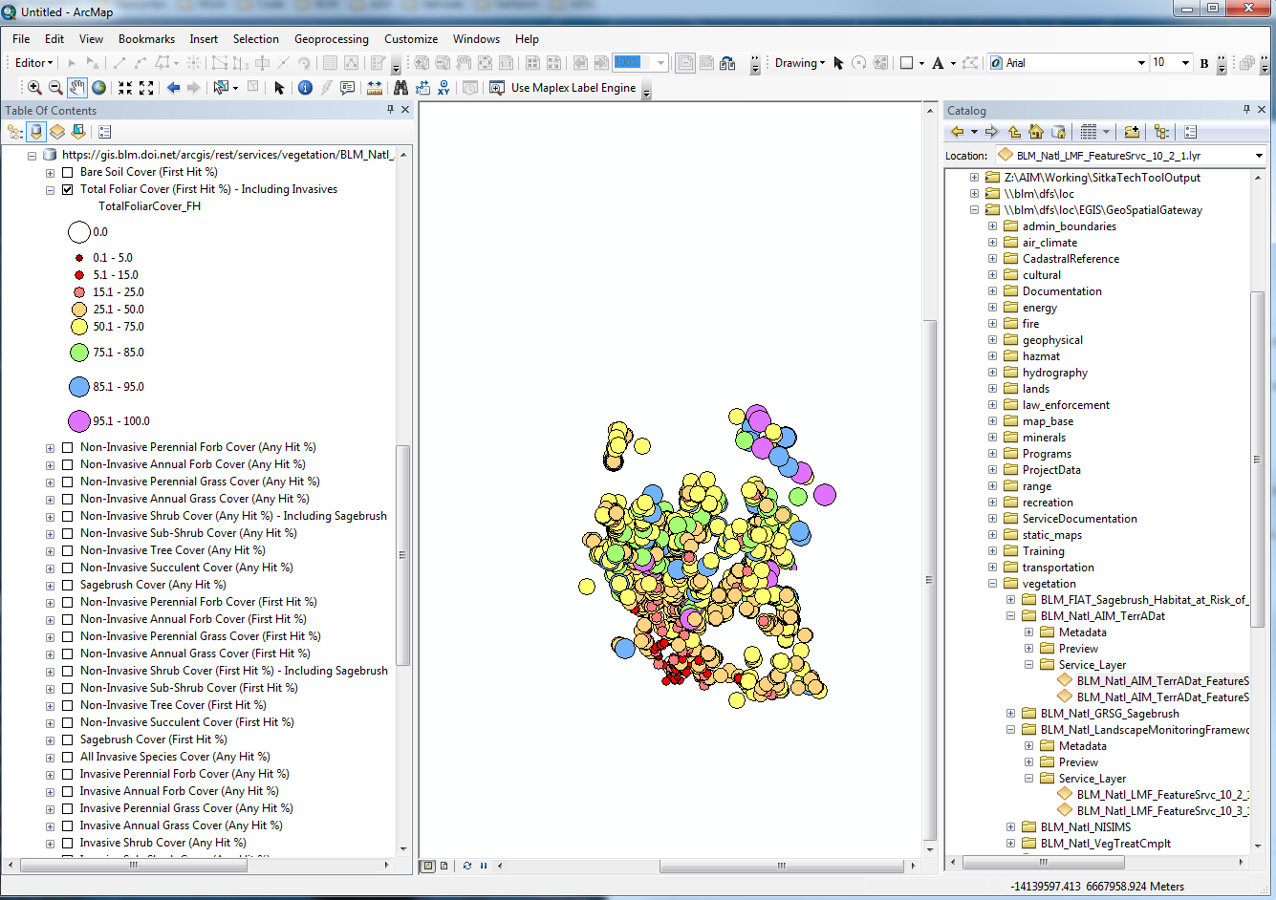
  - Add additional layer files to the map:
    - For BLM boundaries (State, District, Field Office), open BLM_Natl_AdminUnits folder under GeoSpatialGateway, open Service_Layers folder, and add BLM_Natl_Admin_Units.lyr to map. 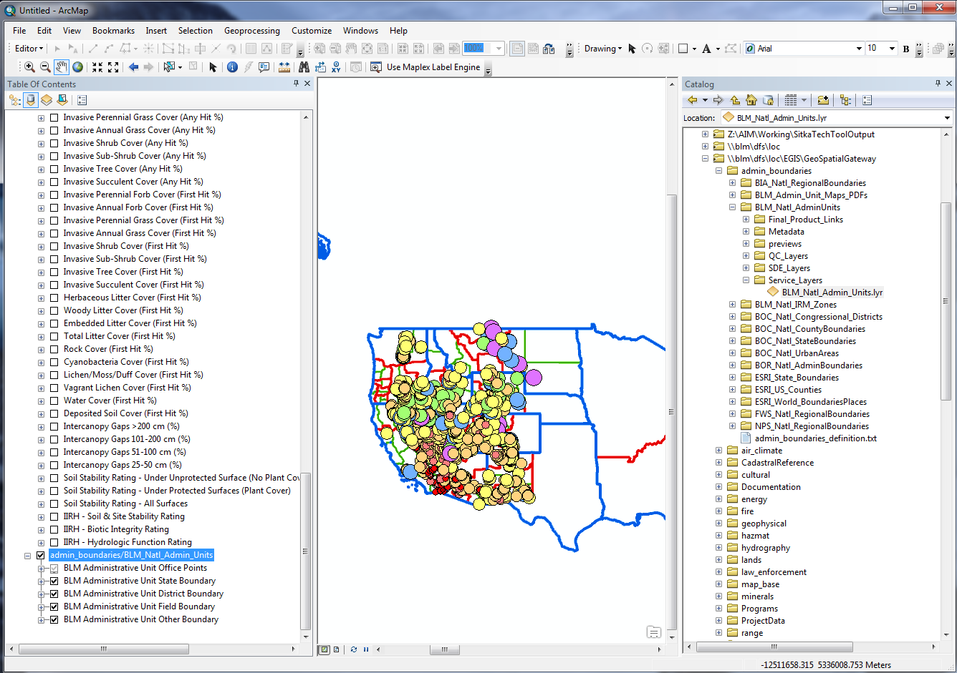
    - Other valuable layers from National BLM Databases:
      - Sage Grouse Habitat layers can be found under GeoSpatialGateway/wildlife/ BLM_WesternUS_GRSG_Proposed_Habitat_Mgmt_Areas_Sagebrush_Focal_Areas/Service_Layer
      - Grazing allotment and pasture layers can be found under GeoSpatialGateway/range/BLM_Natl_Grazing_AllotPast/Service_Layer
      - Wild Horse and Burro layers can be found under GeoSpatialGateway/range/BLM_Natl_WHB/Service_Layer
      - NLCS layers can be found under GeoSpatialGateway/lands/BLM_Natl_NLCS/Service_Layer
      - Land ownership can be found under GeoSpatialGateway/lands/BLM_Natl_SMA/Service_Layers

- Add the layers through Geospatial Gateway website:
  - Open the Geospatial Gateway website in Internet Explorer: https://blmspace.blm.doi.net/oc/intra/drs/SitePages/BLM%20Terrestrial%20AIM%20Data%20(TerrADat%20and%20LMF).aspx
  - Click on the link under the header Feature Service Layer for the dataset you want to download (TerrADat or LMF).
  - A pop-up-box will appear and you can decide if you want to save the layer or open ArcMap with the layer in it – choose whichever you would prefer.

III. Using TerrADat
Once you have your ArcMap set up the way you like it, you are now ready to use the data.

Understanding the layers
  - You will notice that there are a lot of layers in the map when you drop in the single layer file for each database.
  - The layer file is basically a link to the underlying database. For each TerrADat and LMF, the database consists of 3 feature classes (layers).
  - Each layer visible in the map represents an indicator that is stored in one of the feature classes in the database.

If you open the attribute table you can see all the fields in the database and which of the tables the indicator belongs to. You will also see additional indicators that are not visualized in distinct layers in the map. For additional information on this see section IV. Miscellaneous Questions at the end of this document.

How to interpret the layer' symbology
  - You will see that the symbology is essentially the same for all the different layers, with slight variations.
  - Each circle represents terrestrial indicator values at an AIM plot
  - The symbology ranges in color and in size (see graphic below). The size reflects the actual indicator value (e.g., percent cover): the larger the value, the larger the circle. The color reflects a general interpretation of whether the indicator value is good or bad: red = bad while a blue/green/purple = good. 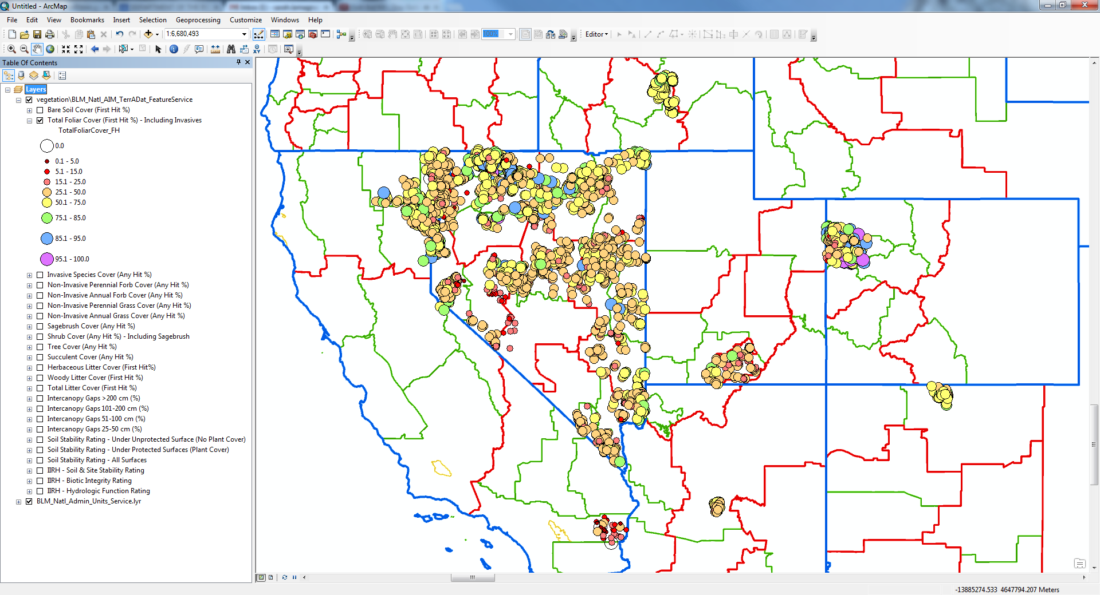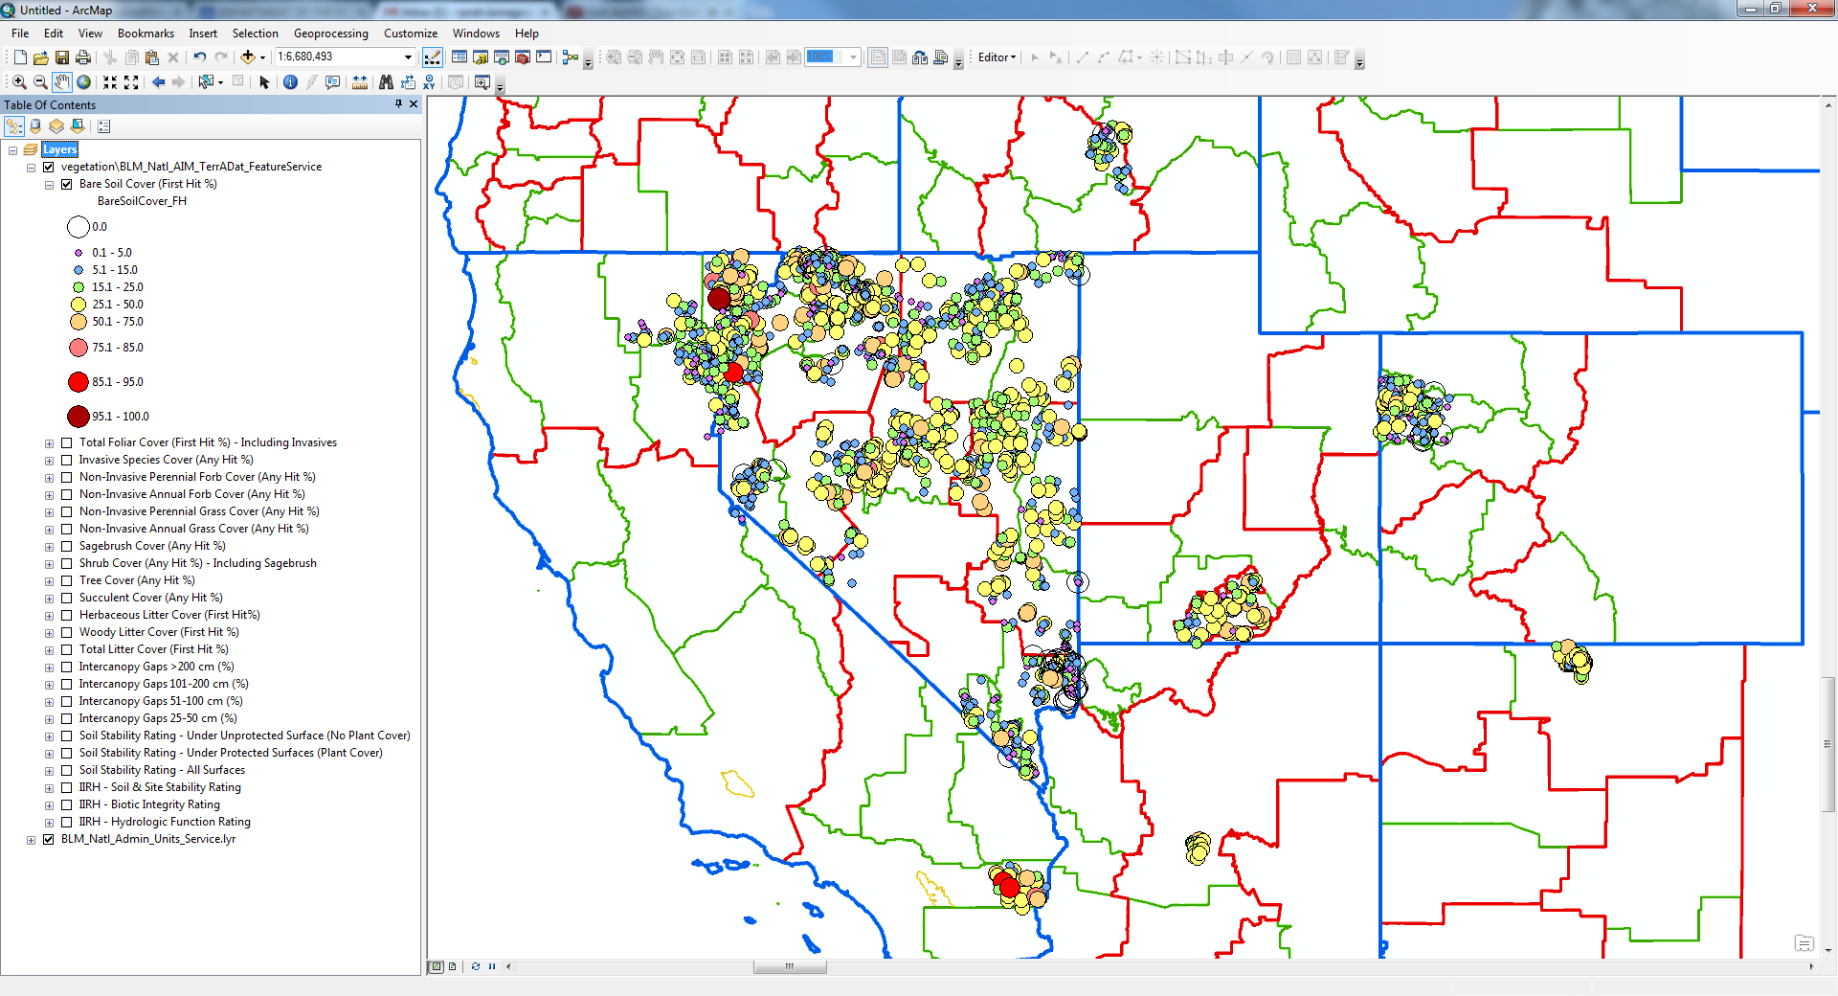
  - It is important to remember that TerrADat currently provides a “snap shot” of resource conditions at individual plots across the nation. This can be used a jumping off point for understanding the data, but more analysis should be done to truly understand the data.
  - If you have questions about statistical analysis of your data, please contact Sarah Lamagna (slamagna@blm.gov, 303-236-6595) or Emily Kachergis (ekachergis@blm.gov, 303-236-0071)

- Changing symbology to your needs
  - You can save the edits you’ve made to your symbology by saving the MXD (ArcMap) to your local drive.
  - There are several ways to change symbology in ArcMap
    - Right click on the layer you’d like to change
      - Click on “Properties”
      - Select the “Symbology” tab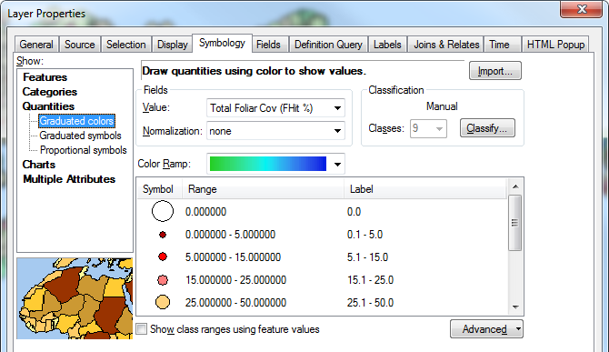
    - You can learn all about changing symbology in ArcGIS here.

Selecting Data to Export
  - Select plots by area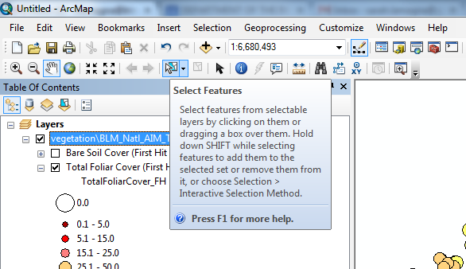
    - Click on the “Select” tool
    - Click and hold while you highlight the plots you want to export
    - Right click on the layer that you want to export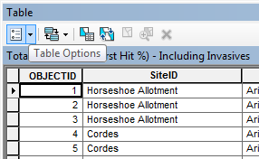
  - Select by location
    - Under the Selection dropdown in the top bar of the map, choose Select by Location 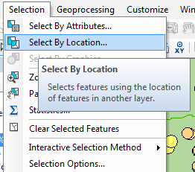
    - In the Select By Location pop-up box, select the layer you want to make a selection on, the Target Layer. This will be one of the layers in LMF or TerrADat.
    - In the Source Layer dropdown select the boundary you want to use as your selection area. If this is a layer with more than feature, you will want to select the desired boundary on the map and then click the checkbox Use selected features. 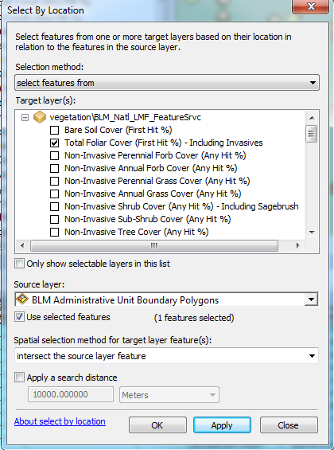
    - Click Apply
    - You will see on the map and in the attribute table, that you have selected a number of features based on the desired location. 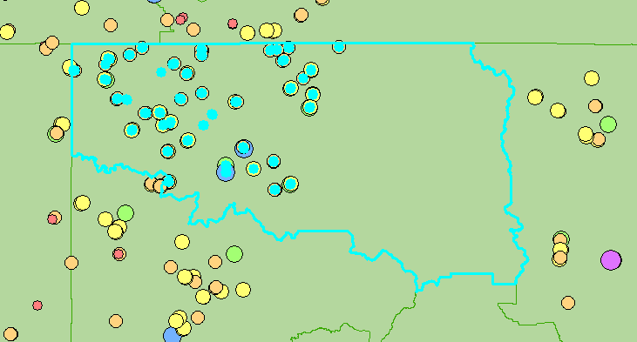
  - Select plots by query
    - Open up the attribute table of the layer you want to export
    - Select the down arrow under “Table Options”
    - Select “Select by Attributes”
    - When the window pops up, double click on “ProjectName” (or any other field of interest) and then click once on the equal sign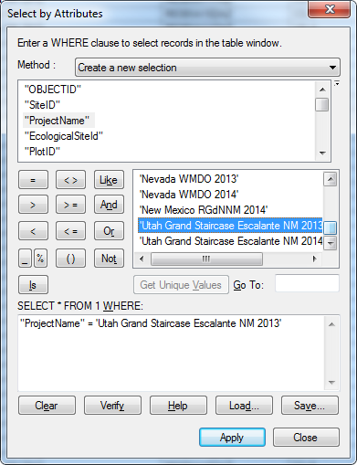
    - Click Get Unique Values and double click on the project associated with the data you’d like to export.
    - Click “Apply”

Exporting Data

Export as feature class (or shapefile).
    - Right click on the layer (in the Table of Contents) that you’d like to export
    - Choose “Data” “Export Data” 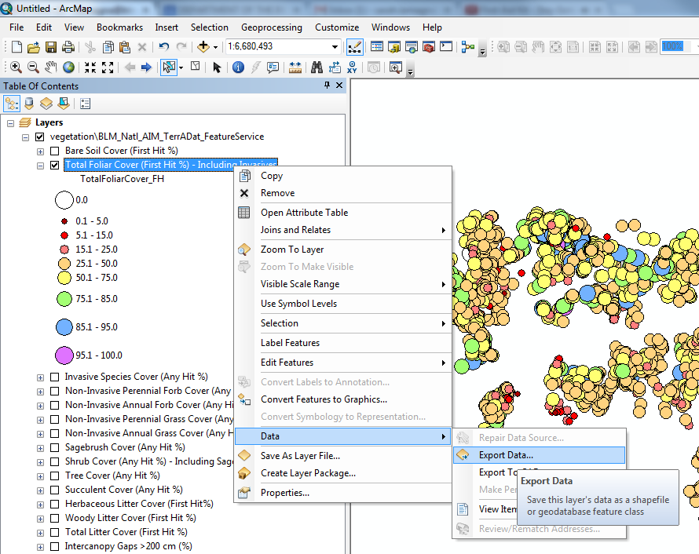

    - Fill out the “Export Data” window
      - Choose which features you want to export: you’ll want to keep the default which is “Selected features”
      - Select the ‘this layer’s source’ data radio button to keep the shapefile in the coordinate system the data is in (WGS_1984_Web_Mercator_Auxiliary_Sphere is the BLM standard for published services and is good for data visualization). 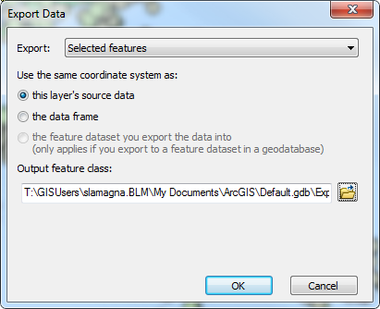

      - Choose a name and location of the file. Make sure the output is in the format you want (shapefile or geodatabase feature classes)
    - Click “OK”

Export to a CSV file
    - Open the attribute table for the layer
    - Click the table options button in the upper left-hand corner of the attribute table window and select “Export”. 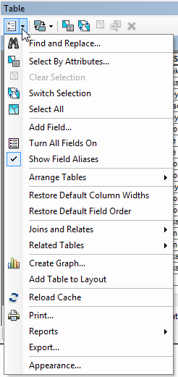
    - Select “Selected records” from the Export drop-down list. Click on the folder icon to change the Output table option to CSV file (see below). 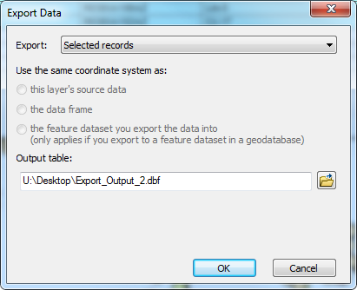

    - Change the “Save as type:” in the Saving Data dialog box to “Text file”. Give the output file a name with a .csv as its extension (e.g., TerrDatOutput.csv). Note the location of where the file will be saved. 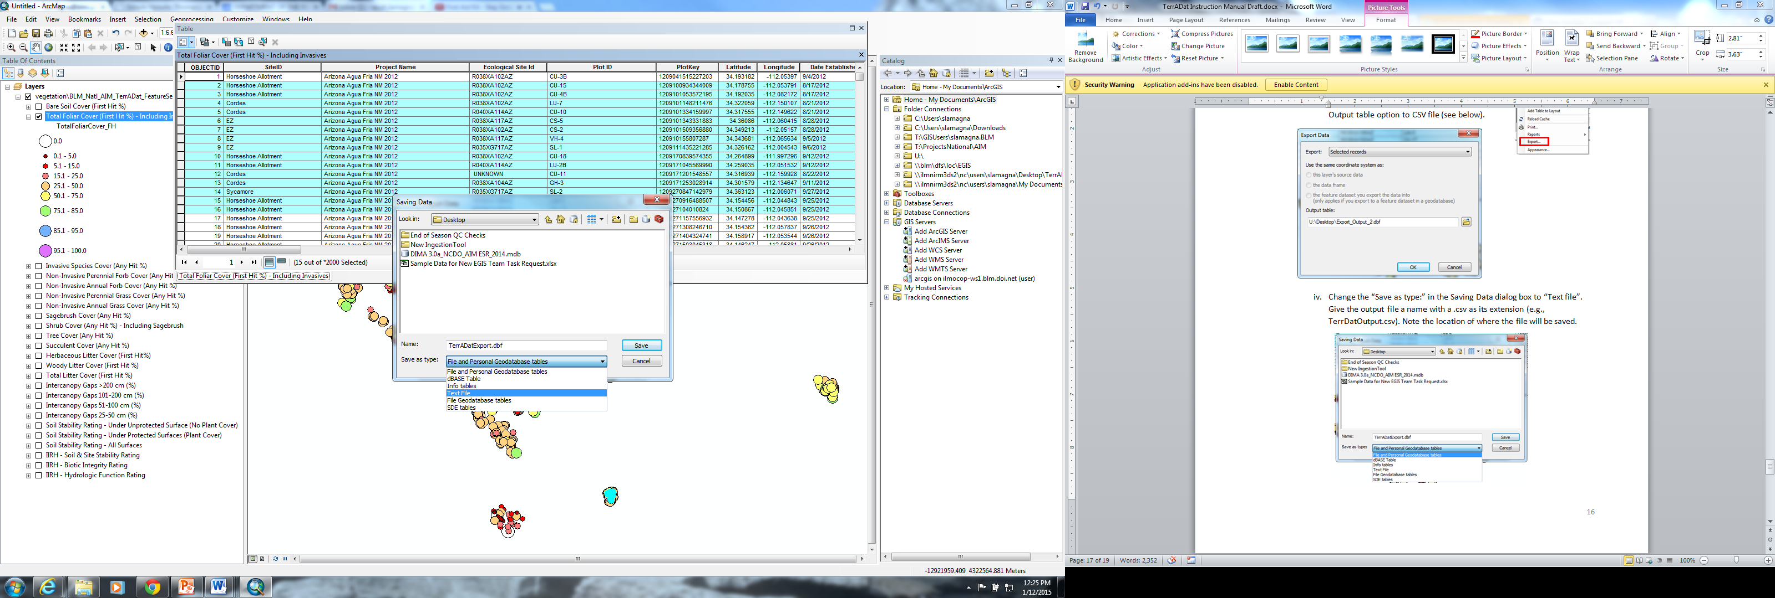
    - Click Save to close the Saving Data dialog box, and then click OK from the Export Data dialog box to save the attribute data to a CSV file. The resulting CSV file can be opened in a spreadsheet application like Excel or imported into one of the Shiny data analysis tools.

Statistical Analyses and Multiple Plot Summaries
  - Summaries of multiple plots (e.g., summaries of indicators by allotment) should take into account the sample design that was used to locate the plots.
    - If you are not familiar with what the sample design was for your project, please get in touch with Emily Kachergis (ekachergis@blm.gov, 303-236-0071) or Sarah Lamagna (slamagna@blm.gov, 303-236-6595)
  - The ARS-Jornada Experimental Range has developed a tool to facilitate these statistical analyses: the Horvitz-Thompson Estimator tool which can be found at the following links –http://shiny.landscapetoolbox.org/HT_Estimator. Instructions for the use of this tool are can be found within the tool itself. 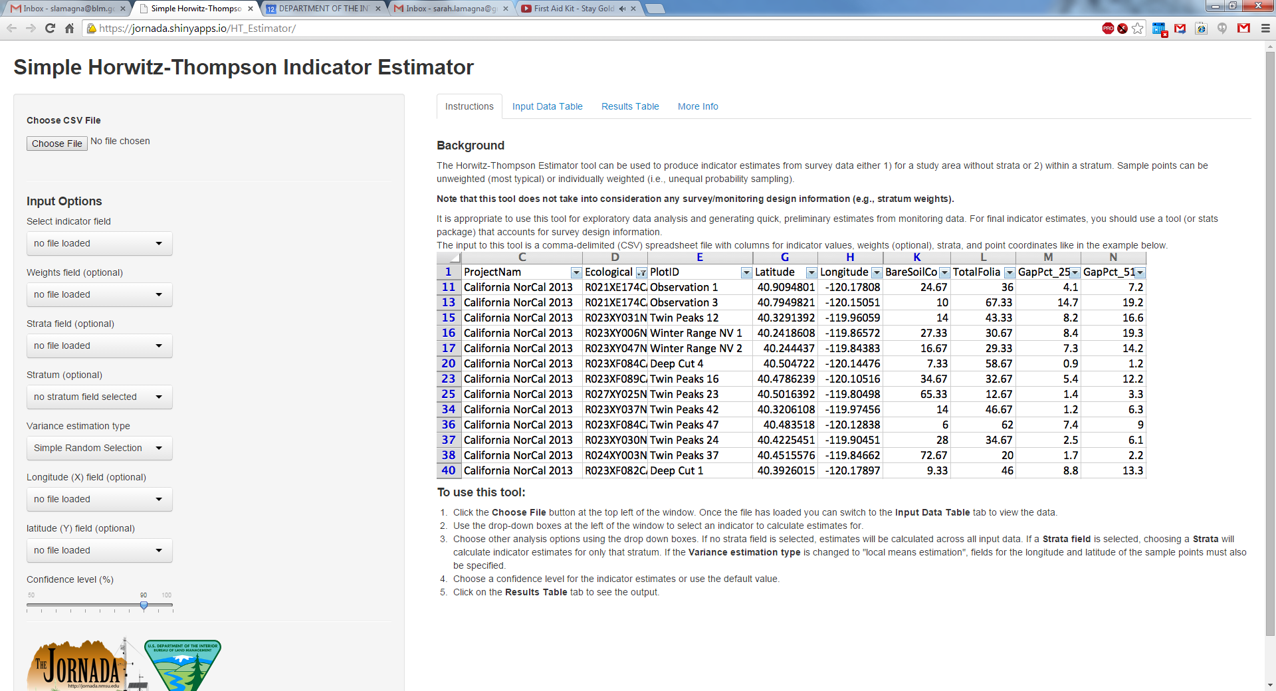
  - If you have questions about statistical analyses of your data, please contact Emily Kachergis (ekachergis@blm.gov, 303-236-0071) or Sarah Lamagna (slamagna@blm.gov, 303-236-6595). If you have questions about the Horvitz-Thompson Estimator tool, please contact Jason Karl (jkarl@nmsu.edu, 575-646-1301).

IV. Miscellaneous questions
A grab-bag of common AIM Data questions answered below.
- What is the schema of the underlying databases?
  - TerrADat has 3 feature classes whose attribute tables contain calculated plot-level indicators (e.g. percent perennial graminiod, percent annual forb, etc.), Terrestrial AIM, Remote Sensing, and Rangeland Health. Terrestrial AIM has total plot summaries (Any Hit), Remote Sensing has top layer plot summaries (First Hit), and Rangeland Health has IIRH data. LMF has the same structure with slightly different feature class names: Terrestrial_Indicators, RemoteSensing_Indicators, and RangelandHealth_Indicators.

- What is the difference between Any Hit and First Hit?
  - Any hit represents if a species was “hit” at any place in the plant canopy (i.e., top canopy, lower canopy, or basal) when dropping the pin at a point along the transect. For example, if you dropped the pin and “hit” cheatgrass first, then Sandberg bluegrass, then bare soil and you were looking at the Perennial Grass (Any Hit %) indicator, Sandberg bluegrass would be incorporated into the calculation of that indicator.
  - First hit represents if a species was “hit” first. Species would be considered First Hit if they were encountered in the Top Canopy while litter, rock, biological crust, lichen/moss, water, and bare soil would only be considered first hit if no species were hit before it.

- Where is vegetation height?
  - Vegetation height is one of the AIM core indicators but is not reflected as a layer in the feature service. It was difficult to create symbology for vegetation height due to large differences in the height depending on what type of plot you were on (i.e., large junipers on plot or no vegetation at all). In order to look up vegetation height for the plots, please refer to the attribute table and the field named “Woody Hgt Avg (cm)” or “Herbaceous Hgt Avg (cm)”. You can download the data (see section IV) and create symbology for it yourself.

- Why are there Null values in certain fields?
  - Null values show that no data was collected for a particular indicator at that plot. They will not show “0” since “0” is considered data.

- How can I access the Metadata for each dataset?
  - In Windows explorer, navigate to \\blm\dfs\loc\EGIS\GeospatialGateway
  - Open Vegetation folder
  - Select which dataset you want to look at, BLM_Natl_AIM_TerrADat or BLM_Natl_LandscapeMonitoringFramework
  - Open Metadata folder
  - Double click on the layer you would like to look at.
  - The metadata will open in Internet Explorer: 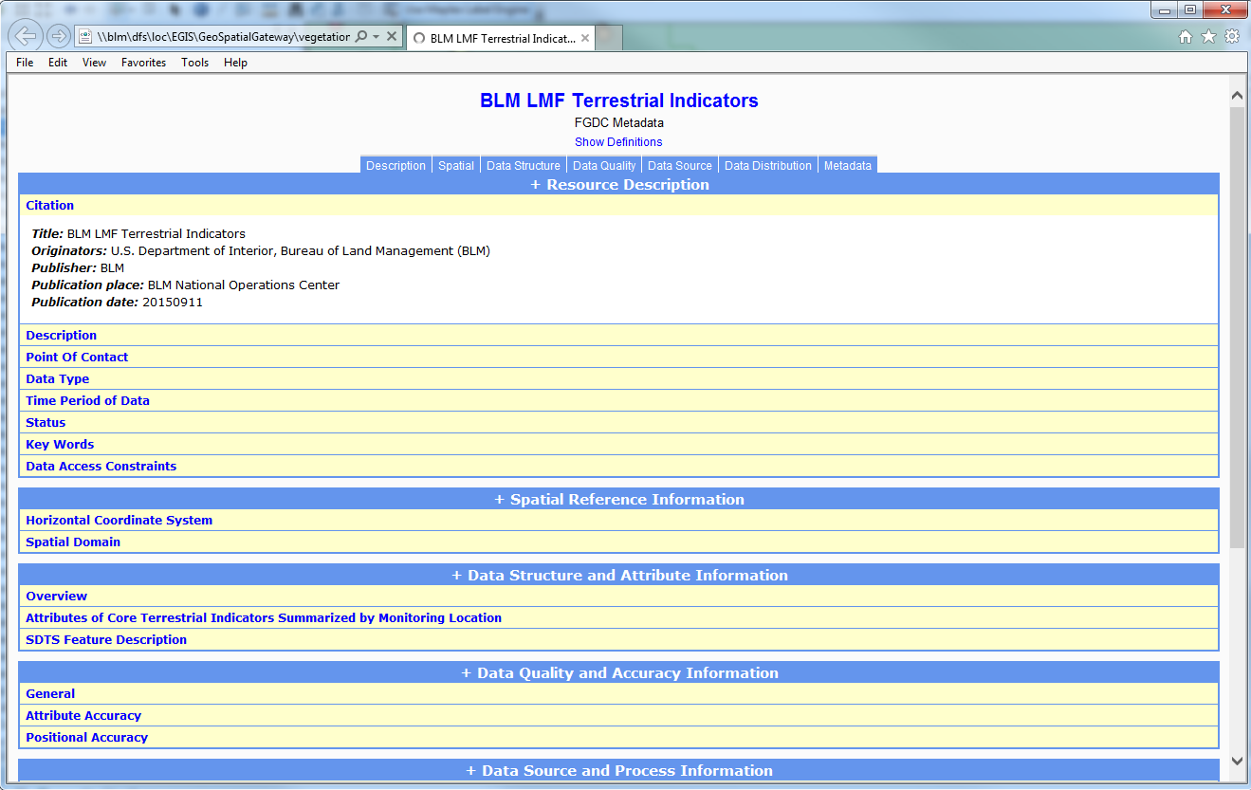
  - The pluses next to each section allow you to expand the section. Click on the ‘+’ next to the Data Structure and Attribute Information to see how each of the fields in the data layer was calculated. 