


BLM’s Terrestrial Assessment, Inventory, and Monitoring (AIM)
2017 Field Season
Data Management Protocol
VERSION 2.0
Produced by BLM National Operations Center and ARS-USDA Jornada Experimental Range – 02/2017

This page is intentionally left blank.

Contents

1.0 Why Manage Data? 4
2.0 Project Lead Data Management 6
3.0 Field Crew Data Management 8
3.1 Field Crew Quality Assurance (QA): During data collection 8
3.2 FIELD CREW Quality Control: After data collection 11
4.0 State AIM Monitoring Coordinator QA and QC 15
4.1 State AIM Monitoring Coordinator QA: during data collection 15
4.2 State AIM Monitoring Coordinator QC: after data collection 15
4.3 Data transfer 15
5.0 National Operations Center QA and QC 16
5.1 National Operations Center QA: during data collection 16
5.2 National Operations Center QC: after data collection 16
References 17
Appendix I. Field Office End-of-Season QC Checklist 18
Appendix II. State Office End-of-Season QC Checklist 19
Appendix III. Terrestrial AIM Ingestion Decision Tree (updated) 20
Appendix IV. End of Field Season Implementation Summary 21
Appendix V. Missing Data/Known Error Tracking Template 23
Appendix VI. Plot Tracking Excel Documentation 24
Appendix VII. Plot Tracking Rejection Criteria 26

Why Manage Data?

Data are the infrastructure of science. Sound data are critical to form the foundation for good scientific decisions and adaptive management.

The purpose of this protocol is to define the Data Management, Quality Assurance (QA), and Quality Control (QC) step for all terrestrial Assessment, Inventory, and Monitoring (AIM) efforts at different levels of management - Project Leads, Field Crews, State Monitoring Coordinators, and the National Operations Center (NOC). This goal of this protocol is to be a guide for how to achieve low levels of error and to establish clear responsibilities for each party involved in the monitoring process.
Project Leads can refer to anyone below the State level who is playing a more active management role in data collection. Oftentimes this is someone at the field office or district level. In some cases, multiple people can participate in the Project Lead roles and responsibilities. There should be BLM staff engaged in this role and this person should have final OK on the data before it is passed to the state level.
Field Crews are the folks actually collecting the data – this can be a crew hired specifically for data collection or field office folks.
State Monitoring Coordinators may be specifically dedicated to AIM or tasked with the responsibilities, but should be someone who is engaged with AIM data collection throughout the entire season, for their entire state.
The National Operations Center refers to the Data Management Team at the NOC who are dedicated to QA&QC at the national level as well as aggregating and serving the data back out. The protocol focuses on field data collected using the Database for Inventory, Monitoring, and Assessment (DIMA) (USDA-ARS Jornada Experimental Range, 2017), which is used exclusively by the Terrestrial AIM program for electronic data capture.

Data management is the process, and means of organizing, and storing data so that these data can be used appropriately to create information and guide sound management decisions. Data management is a key tenet of AIM and is critical to the success of the AIM program. AIM data includes, but are not limited to, management and monitoring objectives (Monitoring Design Worksheet), sample design decisions (Plot Tracking), geospatial input layers, field quantitative data (DIMA), calibration data, field notes, and quality assurance and quality control notes (Missing Data Template), and the final interpretation and assessment of these data (Figure 1 and Table 1).

Quality assurance (QA) and quality control (QC) are the processes of ensuring data integrity and minimizing measurement errors throughout the entire monitoring process (Herrick et. al., 2015). These processes, combined with sound data organization work together to produce a robust data management plan. This document focuses on some of the key data organization and QA and QC steps required for all BLM AIM data.

Although practicing QA and QC may seem tedious, it is a critical step in the monitoring process. Careful attention must be paid to the QA and QC processes because errors in the data will be amplified as the data are used to make land management decisions. QA and QC should be implemented throughout the data life cycle, but in this document we focus on measures that can be taken during and just after data collection.

The spirit of these requirements is to protect us all from a bad investment in monitoring! Rigorous QA and QC strategies make our dataset stronger and more defensible.

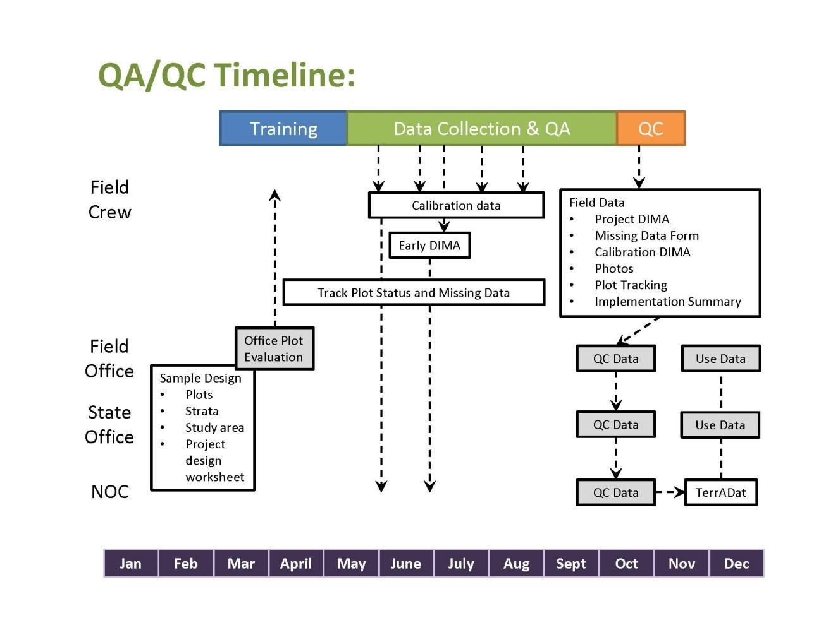
Figure 1. Data Management Timeline
Figure 1 defines the Data Management steps throughout the monitoring process and will shift depending on when your field season begins.

NOC Required Data | Data Management Tool
- AIM Field Data | DIMA (all Project, Targeted, and Intensification plots)
- AIM Calibration Data | DIMA (maintained in separate DIMA database)
- Plot Status | Plot Tracking excel
- Missing data (errors in dataset) | Missing Data/Known Errors template
- Photos | Photo Naming Convention (see 3.2.2 for details)
- Description of the project, season, issues/concerns, successes, etc. | Implementation Summary Template
Table 1. AIM data elements and associated tools.

2.0 Project Lead Data Management

2.1 Before Monitoring Begins
Every monitoring effort needs to have background information regarding the monitoring effort, including monitoring and management objectives, how the sample design was done, the stratification that was used, supplemental methods required to meet monitoring objectives, etc. This information should be documented in the Monitoring Design Worksheet (see aim.landscapetoolbox.org/design) and should be completed with assistance from the National Operations Center (please contact Emily Kachergis, ekachergis@blm.gov for terrestrial efforts). The Monitoring Design worksheet provides a step-by-step template for designing BLM AIM efforts. For additional information on the concepts described in the worksheet, see the AIM Landscape Toolbox site Design Page. This worksheet will need to be filled out prior to field data collection.

2.2 Project Lead Quality Assurance (QA): during data collection
Although the bulk of the QA is done by the field crew, there are specific QA guidelines for the project lead at the field office or district office:
    - Understand the AIM data management process and work to maintain this process year round. Where needed, build local data management practices to handle supplemental data and address additional data needs.
    - Ensure all field crew members understand the AIM methods, have used online training resources, and at the very least that the field crew lead has attended an AIM field methods training in the last 3 years. It is preferred that your whole crew attends training, but with travel and budget limitations, the bare minimum is that the crew lead has attended a recent training (See Appendix III. Terrestrial AIM Ingestion Decision Tree for additional ingestion requirements).
    - Participate in the Office Plot Rejection process – either assist your crew lead in evaluating the plots in the office prior to field sampling or perform this task yourself. For more information see the Sample Point Evaluation page on the website:http://aim.landscapetoolbox.org/office-sample-point-evaluation/. Document these evaluations in the Plot Tracking Excel file (Appendix VI.)
    - Keep communication open with the field crew lead to answer any questions that may arise during the field season. Plant identification and soils in particular may require extra assistance. Direct the crew towards experts if you cannot answer the questions directly.
    - Check up on the field crew (ideally in the field) periodically to make sure they are properly implementing the AIM methods throughout the field season.
    - Ensure that regular calibrations (monthly, when ecotype changes, or when new crew member joins) are completed by checking your field crew’s DIMA periodically.
    - Back up your data.

2.3 PROJECT Lead Quality Control (QC): after Data collection
The project lead gets all data from their field crew lead at the end of the field season and conducts the following QC:
- Check field crew calibration results, once after their first hitch and periodically throughout the field season.
- Quality control (QC) check the field crew’s DIMA, once after their first hitch and periodically throughout the season to ensure data quality. You can use the Field Office End of Season checklist (Appendix I.) as reference for what to look for as well as making sure each method is complete. Make sure to be very thorough at the beginning of the season so the field crew doesn’t consistently make the same mistake. Seek to catch mistakes early.
- QC the field crew’s final DIMA: see Appendix I.
- Maintain close communication with the field crew lead during the QC process – confirm they are following the steps in the field crew section of this protocol.
- Store calibration data in a DIMA that is separate from the project DIMA and send this to your state AIM monitoring coordinator along with your project DIMA and the rest of the data elements outlined in Table 1.
- Update the Monitoring Design Worksheet with any relevant information about the season – changes to the design, challenges addressed, future modifications, etc.
- Make sure that Plot Tracking excel (Appendix VI.) is complete for each plot that was in the sample design (each plot should have a status – Sampled, Rejected or Not Sampled) and that any intensification or targeted plots have been added to the Plot Tracking Excel and the appropriate additional information filled out.
- See that any missing data or known errors in the dataset have been documented by your field crew in the Missing Data/Known Errors excel (see Appendix V.).
- With the assistance of your field crew lead, complete the End of Field Season Implementation Summary (see Appendix IV. End of Field Season Implementation Summary).

Transfer all data/documents within 1 month of the conclusion of data collection or as soon as possible to your state AIM monitoring coordinator (see contact list at aim.landscapetoolbox.org/learn-3/contact/). When sending your final data and documents please confirm all required data/documents are sent. It is best to confirm all data/documents are completed in full with the field crew lead as they are considered the “plot experts” and will be able to assist in developing the documents required.

3.0 Field Crew Data Management

3.1 Field Crew Quality Assurance (QA): During data collection
Do not underestimate the importance of QA steps. Any decisions made in the field will have direct effects on how the data are portrayed at the many levels of use in the future; meaning one data error could be magnified as data are analyzed and interpreted. Follow the basic steps below to help ensure data integrity (Herrick et. al., 2015):

3.1.1 Field Crew General QA

Continuous QA Steps:
- Practice proper technique for all field methods (follow the guidelines in the Monitoring Manual (Herrick et. al., 2015)).
- Maintain data organization (e.g., keep paper data sheets organized, use complete plot names given to you in the sample design, keep DIMA sites organized, etc.). Be consistent.
- If collecting data on paper, input data into DIMA as soon as possible and have a second field crew member check the work (on your data sheets and in DIMA document which crew member entered the data and which crew member checked the data).
- Document errors: record any missing data or known errors in the Missing/Known Error Tracking Template (Appendix V.).
- Solicit expert advice if needed – in particular for plant identification and soils.
- Back up your data.

Daily QA steps:
- Review data forms for completeness and correctness. It is preferable to do this while still at the plot and before transect tapes are rolled up in case information is missing and data will have to be collected.
- Identify unknown plant species. Update those species codes within DIMA.
  - You should not spend a lot of time at a plot identifying unknown plants.
  - If you are unable to quickly identify a plant on a plot, you should follow the Plant Identification Standard Method on page 14 of the 2nd Edition of the Monitoring Manual for Grassland, Shrubland, and Savanna Ecosystems: Volume I (Herrick et. al., 2015).
  - Unknown plants should follow the naming convention outlined in the above method.
- Verify that the end calculations align with your ocular observations (does bare ground % + % foliar cover + between plant cover % = 100 %?).
- Verify that GPS coordinates make sense. Always take a waypoint at the plot in addition to inputting the GPS coordinates into DIMA as a backup. This waypoint should be entered into your Plot Tracking excel directly from your GPS.
- Set the defaults on the GPS and stay consistent throughout the field season. Confirm you are using the same datum every day you are out in the field. DO NOT use NAD27.
- Back up your data after any corrections have been made.
  - Frequently make copies of your DIMA and store it in several places.
  - You should always have a copy on the BLM network when you have come back from the field as this network is backed up regularly.
  - Labeling these versions by date is good way to ensure that you keep track of your various versions.

Weekly QA Steps:
- Review data for completeness and errors with your Project Lead.
- Upload and name photos. Please follow the BLM standard photo naming protocol found in Section 3.2.2.
- Identify any remaining unknown plant species. Update those species in DIMA.
  - If you have attempted to key out unknown plant species and are unable to, seek out a botanist for assistance.
  - Do not leave all species identification to the end of your season - specimens will not last an entire field season.
- Update Plot Tracking excel file (Appendix VI.) with the status of each plot sampled or rejected.
  - Rejected plots should include rejection reason and any associated comments and sampled plots should have waypoint from GPS, date visited, and any other pertinent information.
  - Any plots sampled that were not in your project sample design should be added to your plot tracking excel and labeled as Targeted in the ‘Random or Targeted?’ field. Targeted plots refer to plots that were not randomly placed – one common example is if you sample a key site using AIM methods.
- Back up your data.

Monthly and Change in Ecosystem Type QA Steps:
- Each month or in a substantially different plant community and vegetation structure (e.g., mountain sagebrush to cheatgrass, grassland to PJ encroachment, etc.) than previously encountered, you should calibrate data gatherers (see section 3.1.2) for each method in the protocol (please see the 2nd Edition of the Monitoring Manual for Grassland, Shrubland, and Savanna Ecosystems: Volume I for detailed instructions).
- Store this calibration data in a separate DIMA from your project data.
- Review data for completeness and errors with an ecosystem expert or team leader.
- Back up your data.

3.1.2 FIELD Crew Calibration
Field crew calibration is a crucial part of the quality assurance process. Calibration ensures accurate data collection and guarantees that data are collected consistently among the field crew members, including the field crew lead. Calibration should occur immediately following training, each time data collection begins in a new ecosystem type, when someone new joins the crew (for a day or for the entire season), or monthly, whichever comes first, throughout the field season. During each calibration, the field crew lead should also observe each field crew member for proper technique and should correct methodological problems immediately.
For clear guidance on how to record and document calibration data, please refer to calibration section in the 2nd Edition of the Monitoring Manual for Grassland, Shrubland, and Savanna Ecosystems: Volume 1 (Herrick et. al., 2015). Calibration data should be maintained and given to the NOC along with all other data at the end of the season in a separate, calibration DIMA. Each DIMA should be clearly labeled.

3.1.3 Field Crew DIMA QA
When you are using DIMA to input data, you will notice there are “checks” in place to assure data accuracy. DIMA provides a consistent approach to the data collection of the standardized methods and will help with the quality assurance process. Only data from DIMA will be uploaded into the national Terrestrial AIM Database (TerrADat) (see Appendix III. Terrestrial AIM Ingestion Decision Tree). Use the following basic steps to help maintain your DIMA. Additional information and tutorials on how to perform some of these tasks in DIMA can be found on the Jornada DIMA website (http://jornada.nmsu.edu/monit-assess/dima) and on aim.landscapetoolbox.org.
- Make sure to upgrade to the BLM-approved version of DIMA. Due to upgrade lags within the BLM, the “BLM-approved” DIMA may NOT necessarily be the most current version available from the USDA-ARS Jornada Experimental Range website (http://jornada.nmsu.edu/monit-assess/dima/download). Please check the AIM Landscape Toolbox website (aim.landscapetoolbox.org/data-collection/field-season-preparation-2/) for the DIMA version currently used by the BLM or contact the NOC.
- Be consistent with your naming schema for your sites. Many field crews use the strata from their sample design (BpS, ecological sites, etc.) to separate sites.
  - Make sure you have more than 1 site.
  - Plots will already have a name established when your project receives the sample design shapefile from the Master Sample. DO NOT change your plot name once you’ve received your sample design.
- Identify unknown plant species. Update those species codes within DIMA.
  - You should follow the Plant Identification Standard Method on page 14 of the 2nd Edition of the Monitoring Manual for Grassland, Shrubland, and Savanna Ecosystems: Volume I (Herrick et. al., 2015).
  - Unknown plants should follow the naming convention outlined in the above method.
- Archive old copies of DIMA.
- Keep track of known errors and missing data in the Missing/Known Error Tracking Template (Appendix V.). This will be easier to maintain if you fill it out throughout the season!
- Every so often during field season, an employee from the BLM National Operations Center or your AIM State Monitoring Coordinator will contact the field crew leads/field office data managers to ask for the latest DIMA to ensure data quality. Please be prepared to send the most recent DIMA to them when asked and look for the feedback they give regarding your data.
- Periodically check your own DIMA for errors or missing data. Taking ownership of your data is a necessary part of making this dataset the best it can be! Use the Plot Checklist in Appendix B of the Monitoring Manual to ensure that all data are collected at each plot.

3.2 FIELD CREW Quality Control: After data collection
Field crews collect data using DIMA and follow good data management practices outlined in the Data Entry and Quality Control section of the 2nd Edition of the Monitoring Manual for Grassland, Shrubland, and Savanna Ecosystems: Volume I (Herrick et. al., 2015). Field crews are responsible for the bulk of the quality control conducted throughout the monitoring process. Remember the easiest time to fix a problem is when you are still out at the plot, so always check your data before rolling up transect tapes and leaving the plot for the day.

3.2.1 DIMA QC
- Create one DIMA for the project data (and separate DIMA for calibration data) and confirm that the BLM-approved version of DIMA was used (please see Quality Control section of the aim.landscapetoolbox.org for the correct version to use). This DIMA should include ALL plots associated with a project - if there are multiple projects sampled by one crew (i.e. a separate ESR project and Land Use Plan project, these should be in separate DIMAs).
- If multiple crews collected data for a single project, the DIMAs for those projects will need to be merged.
  - Make sure the species lists in the various crews’ DIMAs are consistent
    - There should not be duplicate unknown species codes in the various DIMAs. Species should have the same growth habit and duration in both DIMAs (Mesquite can be a tree or a shrub – you should select the most common growth habit in your project area).
  - Back up all the DIMAs
  - Merge the DIMAs into a Master DIMA (see the Merging Multiple DIMA databases tutorial on the Landscape Toolbox website: http://www.landscapetoolbox.org/wp-content/uploads/2016/12/Merging-Databases_12152016.pdf).
- Ensure that every plot has a GPS location and has the correct coordinate system/datum/UTM zone (if applicable) entered into DIMA. Checking the plot GPS points against the sample design periodically is a good way to ensure you are using the correct coordinate system and datum and to make sure there are no errors in your GPS protocols.
  - We encourage crews to take additional GPS waypoints at the transect ends at least as backup to the center point. Any additional waypoints are helpful to making sure the location information is captured at the plot, transect ends are helpful because combined with the center point – we have a spatial representation of the entire plot.
- Ensure that plot descriptions were completed in full for every plot. This includes:
  - Directions to the plot (if plot was not a revisit)
  - Plot characterization information: topography, landscape unit/position, slope, etc.
  - Disturbance/management history
  - Azimuths/lengths of each transect
  - Soil pit information (if plot was not a revisit)
- Check and update species codes. If you’ve identified unknowns, make sure these are updated in DIMA.
- Assign growth habit/duration to all species encountered. Species growth habits should be labeled as follows (other labels will not be accepted):
  - Assign species as “Non-woody” or “Woody”
  - Assign a growth habit:
    - Forb/herb
    - Graminoid
    - Tree
    - Shrub
    - Sub-shrub
    - Succulent
    - Non-Vascular (AK only) *
*In the lower 48, Lichen and Mosses are captured as soil surface codes, not growth habits.
  - Assign a duration**:
    - Perennial
    - Annual
**If the species is classified as Biennial only on USDA plants list, please use Annual as the duration.
  - Assign invasive status
    - Yes = Invasive
    - No = Non-invasive
- Run the Method Tracking report in DIMA to check that all data was collected. If any methods have missing data, make sure the information is documented in the Missing data/Known errors document.
    - 3 Canopy Gap forms (unless a different plot layout was used)
    - 3 Line-Point Intercept forms (unless a different plot layout was used)
    - 1 Species Richness form
    - 1 soil stability form (if applicable)
    - Any supplemental method forms (e.g., Interpreting Indicators of Rangeland Health, etc.).
- Correct errors and keep track of any missing data or known errors in the data (Appendix V. Missing/Known Error Tracking Template for a template).
- Ensure only 1 year of data per DIMA.
- Maintain calibration data in separate DIMA to ensure that calibration data and project data are not combined.
- If edits need to be made to previous year’s data, please contact the AIM Data Coordinator (sburnett@blm.gov, /303-236-2716) for guidance.

3.2.2 Other QC
- Ensure plot photos are named following the BLM photo naming convention:
- ProjectName_PlotID_Description_YYYYMMDD
- Descriptions should be labeled as follows:
  - Transects: T1, T2, T3
  - Soil Pits: Soil1, Soil2, Soil3
  - Miscellaneous: Misc1, Misc2, Misc3
- Example: WhiteRiverFO_Alkali-1_T1_20140721
- PlotID’s should match the PlotID in your Plot Tracking excel AND your DIMA.
- Please limit photos to those that are relevant to monitoring (i.e., the required plot photos and scenarios where a second photo is required to completely capture a transect, soil pit, etc.).
- Make sure each plot in the Plot Tracking excel has a status (Rejected, Sampled, or Not Sampled).
  - If the plot was an Oversample or your crew did not get to the plot the status will be Not Sampled). Make sure that all additional, targeted, plots have been added to the Plot Tracking excel and labeled as Targeted.
  - Plots should be labeled as Revisit if they are known revisits. The original Plot ID and original Date Visited should also be populated in the appropriate fields in the Plot Tracking Excel – this information can be gathered from your Project Lead or directly from TerrADat.
- Assist your project lead with the End of Field Season Implementation Summary (see Appendix IV. End of Field Season Implementation Summary Template).

Finally, all data and documents should be sent to the project lead for final approval prior to the crew lead departure. Please consult the Field Office End-of-Season QC checklist to ensure that you’ve completed all QC checks (Appendix I).

4.0 State AIM Monitoring Coordinator QA and QC

4.1 State AIM Monitoring Coordinator QA: during data collection
    - Maintain regular communication with the project leads in the state.
    - Ensure that regular calibrations are completed by checking their DIMA periodically.
    - Maintain regular communication with the National Operations Center.
    - Be a conduit for updated QA and QC guidelines. If changes are made in the procedures, the state leads will be informed about these changes and expected to pass along that guidance.

4.2 State AIM Monitoring Coordinator QC: after data collection
    - Keep each project’s data in its own DIMA.
    - Keep each project’s calibration DIMA separate, but include them all in the final data transfer.
    - Pay special attention to the State Species List and Growth Habit/Subcategory assignments.
    - Make sure there is one Missing/Known Error document associated with each project.
    - Ensure each project has a Plot Tracking excel file associated with it.
    - Back up data.

4.3 Data transfer
The last duty of the State AIM Monitoring Coordinator is to transfer all data/documents, including the document checklist (see Appendix II. State Office End-of-Season QC Checklist), to the National Operations Center. The data should be transferred to the NOC as soon as possible and delays of transfer can affect the inclusion of your data in TerrADat and the distribution of your next year’s sample plots.

- Follow the QC procedures described in this protocol.
- Complete the state document checklist in full (see Appendix II. State Office End-of-Season QC Checklist) and send along with the rest of the data.
- Place all documents in your state’s corresponding folder on the BLM internal network: \\blm\dfs\loc\egis\OC\Xfers\AIM.

When the above have all been completed, send an email to the AIM Data Coordinator (sburnett@blm.gov) and let them know that you have uploaded your data.

5.0 National Operations Center QA and QC

5.1 National Operations Center QA: during data collection
    - Maintain regular communication with the state AIM monitoring coordinators.
    - Ensure that regular calibrations are completed by checking in with projects periodically.
    - Work with the USDA-ARS Jornada Experimental Range to ensure soil samples are sent along to confirm soil texture (part of the calibration exercise).
    - Work closely with the USDA-ARS Jornada Experimental Range on updates to DIMA and determine if/when field crews should transition to a newer version of DIMA.

5.2 National Operations Center QC: after data collection
Each state DIMA goes to the National Operations Center (NOC) data stewards on an annual basis.
- Back up data.
- Convert plots to GCS NAD83.
- Run a report to identify missing data, check to make sure it is accounted for in missing data report. Data will not be accepted and uploaded into TerrADat if:
  - Incorrect/missing GPS coordinates.
  - Plot layout for any given plot is not described.
  - Species growth habits and duration are not assigned.
  - Data forms are missing: 3 Gap intercept forms (unless alternate layout was used), 3 Line-Point intercept forms, 1 soil stability form (if applicable), 1 Species Richness form, and any supplemental method forms (unless the missing forms are documented in the Missing Data/Known errors document).
  - Monitoring Design Worksheet was not completed.
  - Plot tracking excel file was not populated.
  - Missing data are not documented.
  - Please refer to the Terrestrial AIM Ingestion Decision Tree (Appendix III. Terrestrial AIM Ingestion Decision Tree) for further guidance on precisely what data will be uploaded into TerrADat.
- Further inquiry to the SO/DO/FO may be warranted if the following are encountered without an accompanying explanatory document:
  - Soil pit description is missing
  - Plot observations are missing
  - Ecological site has not been assigned

References

Herrick, J.E., J.W. Van Zee, S.E. McCord, E.M. Courtright, J.W. Karl, and L.M. Burkett (2015) Monitoring Manual for Grassland, Shrubland, and Savanna Ecosystems 2nd Edition, Volume I: Core Methods. Las Cruces, NM: USDA – ARS Jornada Experimental Range.
USDA-ARS Jornada Experimental Range (2017, February) Database for Inventory, Monitoring, and Assessment (DIMA). Retrieved from http://jornada.nmsu.edu/monit-assess/dima.

Appendix I. Field Office End-of-Season QC Checklist

Done? | DIMA
 | Have all DIMAs for a single project been merged into one?
 | Did you use/upgrade to the current BLM-approved version of DIMA (see aim.landscapetoolbox.org or contact Sarah Burnett, sburnett@blm.gov for current version)?
 | Are your sites and plots organized well? Are plot names exactly the same in DIMA and Plot Tracking Excel (and your original design)?
 | Is each plot description completed in full (i.e., directions, management, etc.)?
 | Is there a soil pit form completed for each plot (excluding revisit plots)?
 | Are there GPS coordinates for each plot (datum, coordinate system, etc.)?
 | Are there GPS coordinates for each transect in each plot?
 | Are there 3 Gap Intercept forms completed for each plot (unless alternate plot layout)?
 | Are there 3 Line-Point Intercept forms completed for each plot (unless alternate plot layout)?
 | Is there 1 Species Richness form completed for each plot?
 | Is there 1 Soil Stability form (if applicable) completed for each plot?
 | Are all supplemental data entered into the correct DIMA forms (if applicable)?
 | Have growth habits and durations been assigned to all species encountered (see 3.2.1 for details)?
 | Have invasive species been identified in the DIMA species list?
 | Are missing data and known errors documented in the template (Appendix V)?
 | Are calibration data in separate DIMA?
 | Is there only 1 years’ worth of data in DIMA?
 | Is the status of all plots populated in the Plot Tracking Excel File? (See Appendix VI for instructions).
 | Are all photos named using BLM naming convention (described in Section 3.2.2)?
 | Is the Implementation Summary (see Appendix IV End of Field Season Implementation Summary Template) complete?

Appendix II. State Office End-of-Season QC Checklist

Done? | DIMA
 | Is there a single DIMA for each project?
 | Is this DIMA the current BLM-approved version (see aim.landscapetoolbox.org or contact Sarah Burnett, sburnett@blm.gov for current version)?
 | Does each project have a separate calibration DIMA?
 | Are plot names in your projects’ DIMAs exactly the same as the original design and the Plot Tracking Excel?
 | Are all plant species on the state species list (if your state maintains a state species list)?
 | Do all plants encountered have an assigned growth habit/duration (see 3.2.1 for details)?
 | Are missing data and known errors documented (see Appendix V)?
 | Is the status of all plots populated in the Plot Tracking Excel File?
 | Are all projects’ photos named using BLM naming convention (see Section 3.2.2)?
 | Is implementation Summary (see Appendix IV. End of Field Season Implementation Summary Template) complete?

Appendix III. Terrestrial AIM Ingestion Decision Tree (updated)

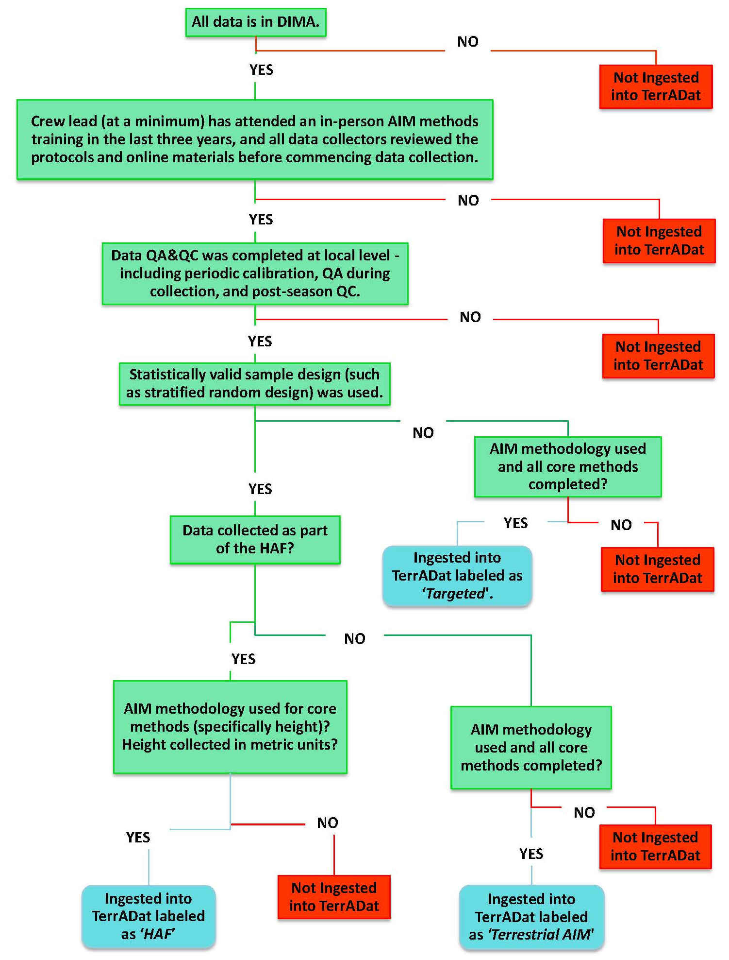

Appendix IV. End of Field Season Implementation Summary

PURPOSE: The AIM implementation summary is intended to provide an overview of each project’s implementation efforts and to capture lessons learned. This information will be used to improve the AIM implementation process in future years as well as serve as a resource for new implementation efforts. To help better understand each part of the AIM implementation process, we have broken down this summary into several components: plan and fund, design, training, data collection, QA and QC, storage, and analysis and reporting. We have also included a section on your experience working with AIM, as well as a general section at the end for comments or questions that we may have missed. We thank you in advance for your valuable input.
AIM Implementation Details
Project Lead Name
Location
Cost
# Plots sampled in 2017
Project area 2017
Data collection start date
Data collection end date
Number of field crews
Field crew size
Field crew training date(s) and location
Field crew calibration date(s)

Plan and Fund:
Briefly describe the planning and funding process, including mechanisms, timeline, resource availability, etc. What worked well about this step? How could planning and funding be improved?
Design:
Briefly describe the design phase, including your experience filling out the Monitoring Design worksheet, engagement with the NOC/Jornada/NAMC and your local resource staff, and approach (study area, stratification, sample size). What recommendations would you make to better implement this portion of the process?
Field Season Preparation and Training:
Briefly describe the field season preparation and training process. Were you able to hire crews and gather materials in the necessary time frame? Was the training adequate? Do you have any recommendations to improve content, structure, presentation of materials that could assist future crews? Was all the information covered in the training allowing you or your crews to successfully carry out the field season? How can we improve training and field season preparation?
Data Collection:
Briefly describe the data collection portion of the field season, including timeline, data management, and supplemental indicators (if any) collected. What was your experience coordinating and managing crews? Was there adequate support available from the SO/NOC/Jornada during this phase? What recommendations would you make to better implement this portion of the process?
Data QA and QC:
Briefly describe your data quality assurance (QA) and quality control (QC) process. How often did the crews calibrate? Was this an effective tool for ensuring data quality? Was the data correction and completeness process adequate? What was your experience working with the NOC/Jornada on QA and QC? How can this process be improved?
Storage:
Briefly describe your experience working with DIMA and TerrADat/AquADat. What was your experience working with the NOC to submit data? Is there anything you would recommend to improve the process?
Analysis and Reporting:
Briefly describe your analysis and reporting using AIM data. Who is involved in this step? What are realized benefits and challenges of using AIM data in your reports? What other resources or tools would be helpful in this process? How will these analyses and/or reports be used?
Data analysis and reporting applications (check all that apply):
- Land use plan effectiveness
- Watershed assessment
- Treatment effectiveness
- Grazing permit renewal
- Sage grouse habitat assessment
- Energy development monitoring
- Other:
- Other:
- Other:

Working with the AIM team:
Briefly describe your experience in working with the National AIM team. Please comment on organization, communication, direction, availability of appropriate expertise. How can the AIM team provide be more supportive to AIM implementation across BLM?
General:
Do you have any additional thoughts, suggestions or comments to improve AIM implementation in the future?

Appendix V. Missing Data/Known Error Tracking Template

Site ID | Plot ID | Line # (if applicable) | Point # (if applicable) | Missing Data/ Known Errors | Reason/ Explanation
Example Site 1 | Example Plot 1 | 1 | 20 | Missing height measurement | Forgot to measure – could not get back to plot to get measurement
Example Site 2 | Example Plot 2 | N/A | N/A | Missing soil stability | Could not find paper data sheet – could not get back to plot to get measurement
Example Site 3 | Example Plot 3 | 2 | N/A | Missing azimuth | GPS was corrupted and data was lost

Appendix VI. Plot Tracking Excel Documentation

- The Plot Tracking excel file (aim.landscapetoolbox.org/office-sample-point-evaluation) is intended to help you track your plots throughout the season. In the Plot Tracking tab all plots visited should have a row including plots added to the sample design throughout the season (if, for example, you add a revisit plot at the end of the season or a key site in an allotment) and all plots should have a status. If you worked with the NOC to draw your design you should have received a populated version of this excel, if not see above link.
Field | Description | Values
Plot ID (Plot Name) | This is the Plot Name – corresponds to the Plot Name used in your DIMA. For the case of designs completed and given out by the NOC, this field will be populated for you. Please do not change the name of the plot if it’s prepopulated. If you add targeted plots or SHINY plots, add them below the design given to you by the NOC or populate yourself if you’ve done your own design. | NONE
Panel | This field indicates Base vs OverSample Plots. Base plots will have a value that corresponds to the year of your design that you are in (i.e. Year2 if you are on the 2nd year of a 5 year panel). A third value such as ‘2017 Intensification’ or similar will indicate plots that are outside of your original design. These may be intensification plots. | NONE
Plot Status | Final Status of Plot (Rejected, Sampled, or if the plot wasn’t visited or if it was an oversample, Not Sampled). This field should be completely populated at the end of your field season including any additional plots you added to your design. | Rejected, Sampled, Not Sampled
Administrative State | The BLM state in which this project took place. | BLM States
Project Office | The BLM office (field, district, or state) in which this project took place and was managed out of. | BLM Offices
Design Stratum | This is the stratum that the plot was supposed to be in during the design portion. This field should NOT be changed after the sample design phase. To identify which stratum your plot actually landed in, please edit the Actual Stratum Field. | NONE
Project Contact Name | This field should contain the Project Lead or main contact name; this can be the same for all plots. | NONE
Contact Info (Email, Phone) | This field should contain the contact information – email address and phone number- for the above Project Lead or main contact; can be the same for all plots. | NONE
Comments | If you have any comments about the plot, please put them here (e.g. Plot was difficult to visit, gate closed, Animal on plot) | NONE
Rejection Criteria | If you sampled the plot, then populate this field with one of the Target Sampled (in expected stratum or not in expected stratum) options. If you visited but could not sample the plot, then select the Field rejection value appropriate. If you did not visit the plot then select the Office rejection that is appropriate – see Appendix XII for the entire rejection criteria list. | Terrestrial Rejection Criteria, see Appendix XII.
Rejection Criteria Comments | If you have comments regarding the reason for rejecting the plot, note them here. | NONE
Actual Stratum | This is the field in which you note the actual stratum in which the plot was located. It may or may not be the same as design stratum. This should be based on field verification. If you did not visit the plot, leave this field blank. | NONE
Project | What project the plot is associated with, if applicable. This information will be transferred to the national database. Goal of this field is for filtering purposes and should be approved by the Project Lead. If point is not part of a special project, this value will just be Terrestrial AIM. If your project is not in the dropdown, feel free to write it in! | ESR/Terrestrial AIM/ /Habitat Assessment Framework/ Solar Energy Zone/Treatment Effectiveness/Range
Random or Targeted? | This field describes the sample design used to select the plot. For any plots given to you by the NOC, these plots will be Random. For additional plots added to your design, this will be Random if you used SHINY or a statistically valid, spatially balanced, point generator. If you have plots added that were not selected in the above ways, this field should be Targeted. | Random-NOC or SHINY generated design/Targeted
Revisit? | Is this plot a revisit plot? Please consult your project lead if you are unsure. | Yes/No
Original Plot ID (If Revisit) | If this is a revisit plot, this field should contain the plot ID of the original plot (this should correspond to the Plot ID that is in TerrADat). | NONE
Date Originally Visited (If Revisit) | If this is a revisit plot, this field should contain the Date the plot was originally visited. | NONE
Moved Plot? | Did you move your plot? | Yes/No
Move Comments | Where did you move it and what was your reason for moving the plot? | NONE
Date Visited | If the plot was sampled, this should be the date the plot was sampled. | NONE
Actual Latitude (Y) | Populate this field with the actual Latitude of the plot that was visited, this should be from the GPS unit waypoint that is taken at the center point of the plot. | NONE
Actual Longitude (X) | Populate this field with the actual Longitude of the plot that was visited, this should be from the GPS unit waypoint that is taken at the center point of the plot. | NONE

- The Plot Proportions tab has a section (Collected – blue) that will auto-populate as you fill out the Plot Status field in the Plot Tracking tab. This table is to help you keep track of the proportions of each strata that you/your crew has sampled. The goal is to sample in proportions similar to the design that was drawn. For your reference, the original design proportions are in the Sample Design (orange) portion of the table and will stay static.

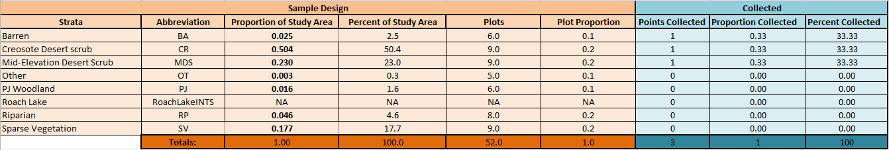

Appendix VII. Plot Tracking Rejection Criteria

DOMAIN | DOMAIN DESCRIPTION
Office - Unsafe to sample | Office Rejection Criteria: Sample point is unsafe to sample.
Office - > 3 miles walking distance | Office Rejection Criteria: Sample point is >3 miles walking distance from the closest point accessible by a vehicle.
Office - Non-BLM land | Office Rejection Criteria: Sample point falls on non-BLM land.
Office - Slope > 50% | Office Rejection Criteria: Slope of sample point exceeds 50%
Office - Access Denied | Office Rejection Criteria: Access to the point was denied: (Information below should be put in Rejection Criteria Comments field)  - Access route unsafe  - Access required passage through non-BLM land, access was denied  - Owner contacted on _______________________.  - Locked gate  - Access denied but visit rescheduled for ___________________________.
Office - Transect crosses boundary | Office Rejection Criteria: (Optional, determined by the monitoring objectives) The sample point transect crosses a boundary between different management units (e.g., in an allotment-scale monitoring project, the sample point intersects two allotments).
Field - Unsafe to sample | Field Rejection Criteria: Sample point is unsafe to sample (e.g., unstable soil surface, cliffs, hazardous wildlife, law enforcement concerns).
Field - >3 miles walking distance | Field Rejection Criteria: Sample point is >3 miles walking distance from the closest point accessible by a vehicle.
Field - Slope > 50% | Field Rejection Criteria: Slope of sample point exceeds 50%.
Field - Access Denied | Field Rejection Criteria: Access to the point was denied: (Information below should be put in Rejection Criteria Comments field)  - Access route unsafe  - Access required passage through non-BLM land, access was denied  - Owner contacted on _______________________  - Locked gate  - Access denied but visit rescheduled for ___________________________
Field - Intersects wetland, riparian, or aquatic feature | Field Rejection Criteria: (Optional, determined by the monitoring objectives) Sample point transect intersects wetland, riparian or aquatic feature.
Field - Intersects Road | Field Rejection Criteria: Sample point transect intersects a road or primitive road.
Target Sampled - in expected stratum | Target was successfully sampled (thus NO rejection) and it was in the expected stratum (Design Stratum and Actual Stratum fields will be the same).
Target Sampled - not in expected stratum | Target was successfully sampled (thus NO rejection) and it was NOT in the expected stratum (Design Stratum and Actual Stratum fields will be different).
Site not sampled | Site was not sampled (this should be used for Over Sample points or points that were not gotten to by field crews, but not actually rejected).
Temporarily Inaccessible | If the site was temporarily inaccessible, then select this option and elaborate in the Reject Criteria Comments field as to the nature of the temporary inaccessibility.
Archeology Site | If evidence of archeology site is found, and the site is rejected for that reason, please select this option.

