Merging DIMAs/Importing Into A DIMA Tutorial

- Create a master DIMA database using the BLM approved version (as of July 2016, use version 4.1a). This is the database that always takes precedence and the one that you import data into.
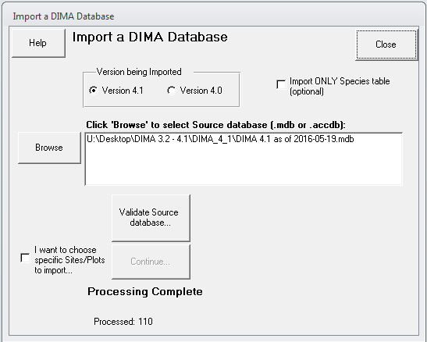
- With your master DIMA database open, click on “Administrative Functions” and under Data Management, select “Data Imports/Exports”. You’ll have to input your password which should always be 9999 (please don’t change this password).
- Select “Import ALL data from another DIMA database” and “Browse” to where the first DIMA is located.
- Double check the DIMA that you are importing.
- Select which version you are importing from (4.0 or 4.1 – if your DIMA is a in a version prior to 4.0, you will have to download an earlier DIMA version and step through the versions to the current one, i.e. if you are in 3.1 you will have to import into a version 3.2 DIMA, then a version 4.0 DIMA, then you can import into 4.1a).
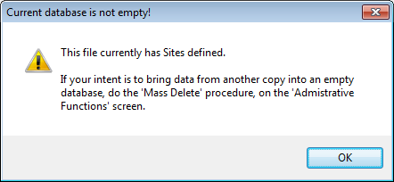
- Once the field office DIMA is selected, click on “Validate Source Database” and it will let you know if the field office DIMA is good to upload. If it isn’t, please follow the steps in DIMA to rectify the error. You may get a message stating that the current database (your state master DIMA) is not empty, just click “OK”.
- You must select which database takes precedence in case there are duplicate records (there shouldn’t be). You’re state master DIMA (or “THIS”) database will always take precedence.
- If you want to only import specific plots, select the “I want to choose specific Sites/Plots to import…”. To import all data, click the “Continue” button and it’ll ask you if you’re ready.
- Once you select “Yes”, the DIMA will be imported, which may take some time. Three windows will pop up at the end to summarize what data were imported and updated.
- One thing to note is that plant species will be updated as each DIMA is uploaded into the state master DIMA – be careful to note what exactly has been updated. This is one reason we suggest never repeating generic species codes – if you have PG01 in both DIMAs, the merging process assumes that these are the same speces.

Updating A Species Code in DIMA

- Many times in the field you’ll come across unknown plant species. You’ll want to try your best to identify those species as soon as possible (if you can’t do it out in the field). You’ll still have to input something into DIMA – please follow the unknown plant naming protocol in the Plant Identification section in the Monitoring Manual for Grassland, Shrubland, and Savanna Ecosystems: Volume I (Herrick et.al., 2015). Once you’ve identified the plant species, you’ll have to go into DIMA to change the species name. It’s easier and introduces less error to do a bulk update though rather than changing it individually.
- With your DIMA database open, click on “Administrative Functions” and under Data Management, select “Mass Update of a Species code within a Site/Plot”. You’ll have to input your password which should always be 9999 (please don’t change this password).
- Specify the site the unknown species was found (if it was across the whole field office, you’ll have to do it for each site individually).
- If it was only found on one plot, you can select the plot as well although this is optional.
- Select the species code it was before (e.g., AF04, etc.) and then input what you want to change the species code to (e.g., BRTE, etc.).
- Select “Do mass update” and DIMA will update the species code for that site or plot depending on what you selected.
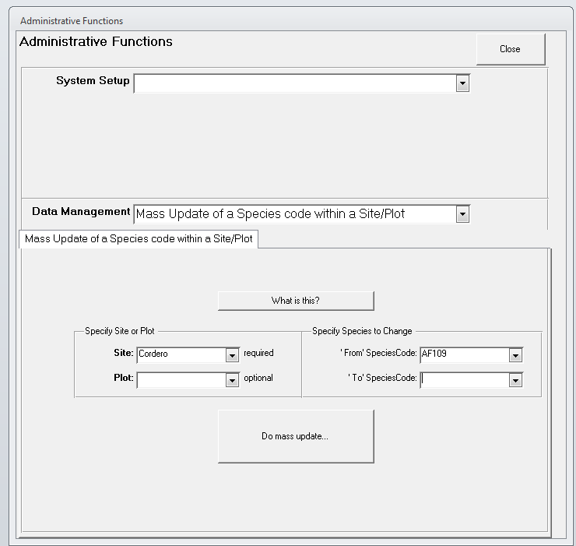
- Repeat for any other sites.

Method Tracking Report in DIMA

- As part of the QC process, you’ll have to confirm all methods were done for each plot.
- With your DIMA open, select “Reports”.
- Under “Select Method”, select “Method Tracking”.
- Select all your Sites and Plots.
- Click on the “Select Report” tab and highlight “Method Tracking Report”.
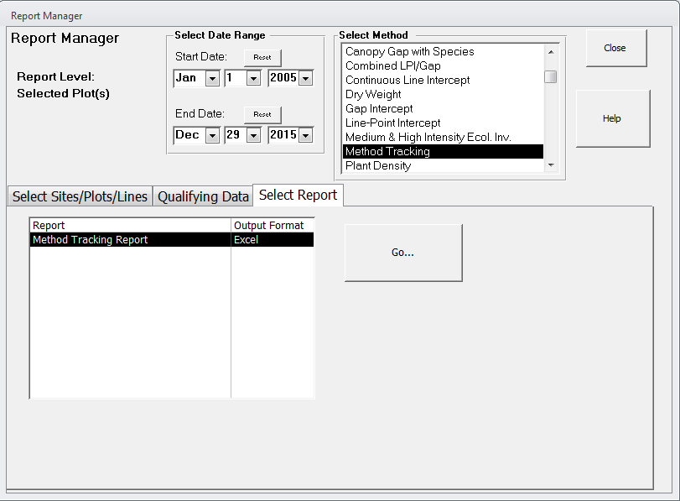
- Click “Go”.
- An Excel Worksheet will pop up when DIMA is finished running the script.
- Open up the Excel Worksheet and see where data forms might be missing. One thing to note is that this form does not show if there’s any data within the form missing, you’ll have to go into each form individually to check that.
- If data forms are missing (e.g., only 2 LPI forms for one plot, etc.): first try to find the missing data and if data cannot be found, document the missing data in the missing data/known error tracking template.

Exporting data by year in DIMA

A lot of times, projects like to keep multiple years’ data in one DIMA, however only the current year’s data can to be sent to the AIM state monitoring coordinator and on to the NOC. Please follow the steps below to ensure that:
- Create a new DIMA database.
- With your new DIMA database open, click on “Administrative Functions” and under Data Management, select “Data Imports/Exports”. You’ll have to input your password which should always be 9999 (please don’t change this password).
- Select “Import ALL data from another DIMA database” and “Browse” to where the original DIMA is located.
- Double check what version of DIMA the original DIMA is and check the box for which version is being imported.
- Once the DIMA is selected, click on “Validate Source Database” and it will let you know if the DIMA is good to upload. If it isn’t, please follow the steps in DIMA to rectify the error.
- You must select which database takes precedence in case there are duplicate records (there shouldn’t be).
- Select “I want to choose specific Sites/Plots to import…” and click “Continue”.
- Highlight all Sites and Plots and under “What to Import?” select “Site/Plot Definitions AND Method data”.
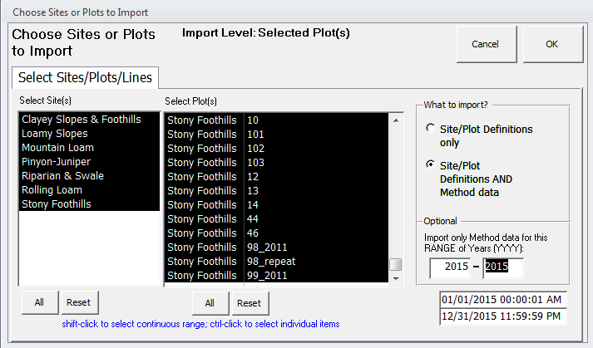
- Under “Optional: Import only Method data for this RANGE of years (YYYY): enter the current year in both blank spaces. (e.g., 2015 – 2015).
- Click “OK”.
- It will ask you if you’re ready for the database to be updated. Click “Yes”.
- Confirm only the current year’s data was uploaded.

Confirming State Species List Tutorial

- On the DIMA home screen, click on “Reports”
- Under “Select Method”, highlight “Species Reports”.
- Select all sites and plots.
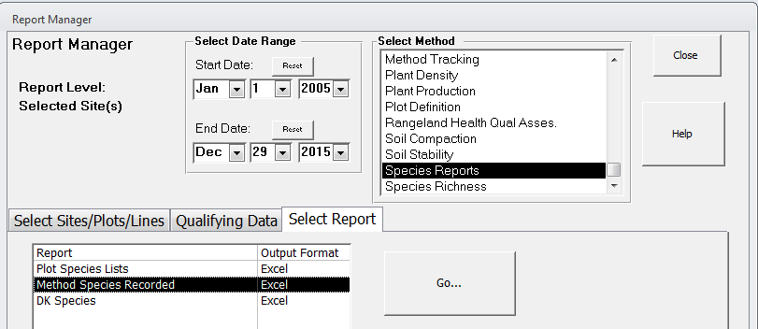
- Click on the “Select Report” tab and highlight “Method Species Recorded”
- Click “Go”.
- An Excel Worksheet will pop up. Select the “Recorded Species” tab.
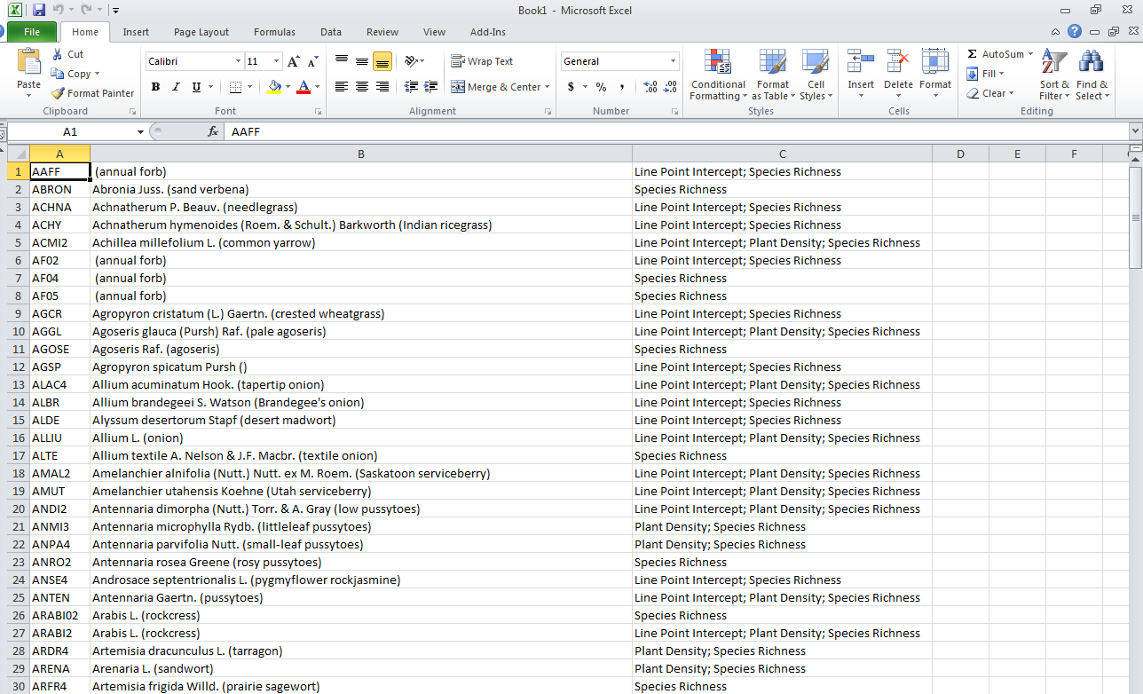
- Go through the list to confirm that all species make sense for your state.

Downloading GPS Coordinates from DIMA

- In your DIMA, select Report on the Home Screen.
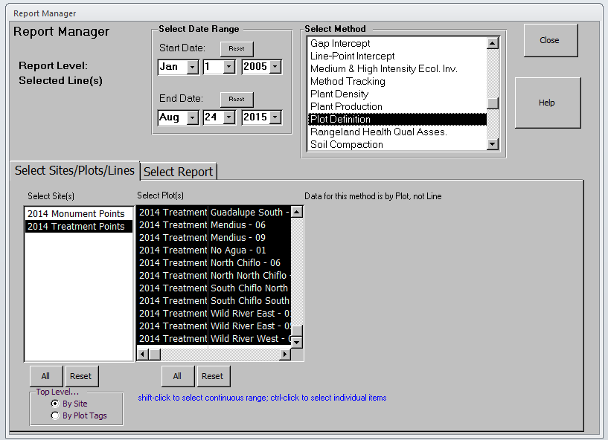
- Select “Plot Defintion” in the Select Method list box, then highlight the desired Sites and Plots in the Select Site(s) and Select Plot(s) list boxes.
- Click on Select Report tab and highlight the Soil Verification.
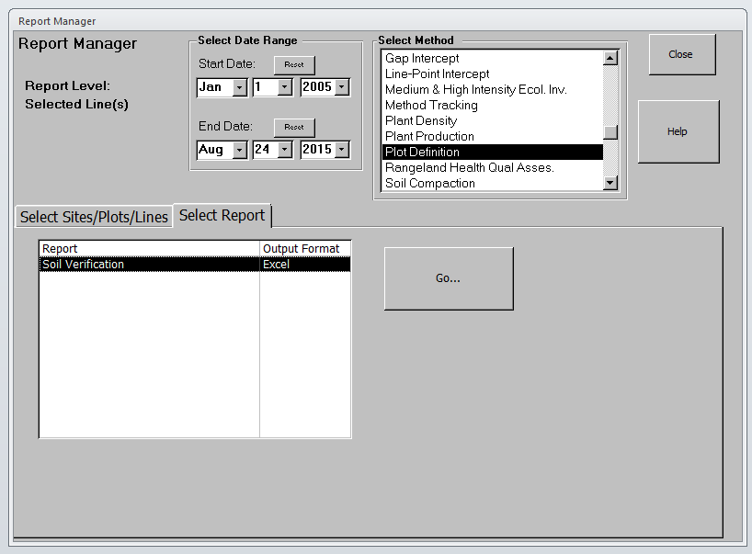
- Click “Go”.
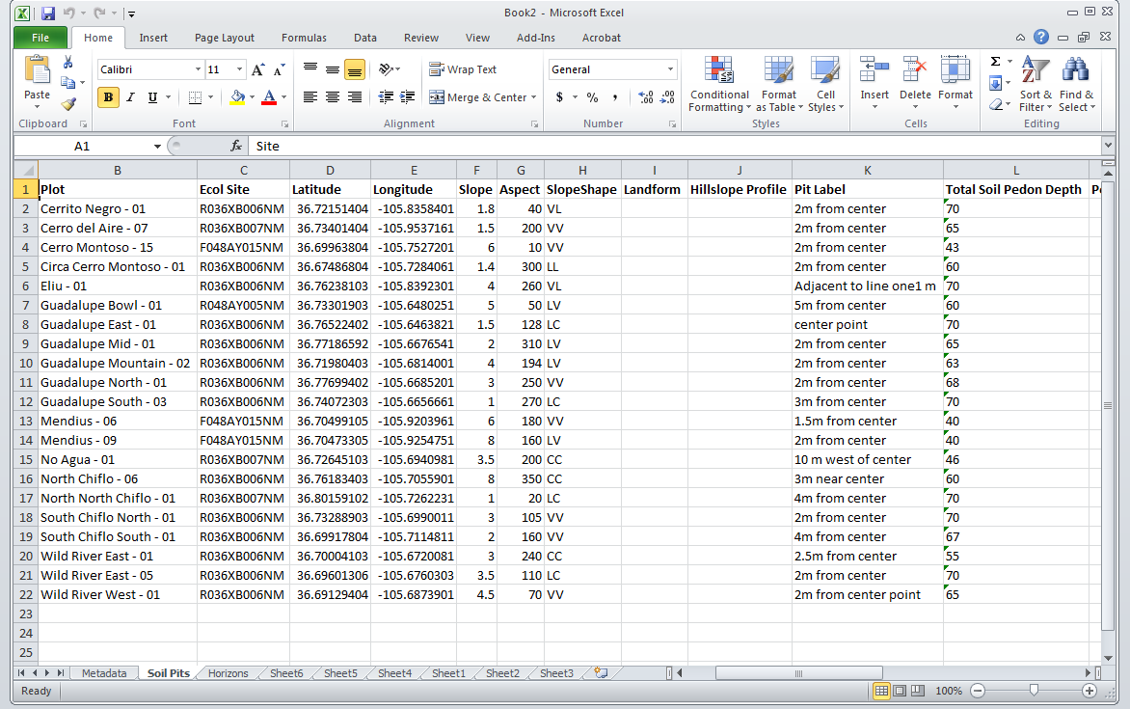
- An Excel Worksheet will display. Click on the “Soil Pits” tab. This tab contains 2 columns labeled “Latitude” and Longitude”. These are the fields that will be loaded into the Actual Points feature class (part of the sample design geodatabase).

