DIMA Home Screen

- Open DIMA database.
- Check that macros are enabled. File Options Trust Center Trust Center Settings Macro Settings select “Enable all macros (not recommended; potentially dangerous code can run” radio button. If you are having trouble viewing data in DIMA or getting functionality, this is likely the issue.
- Home Screen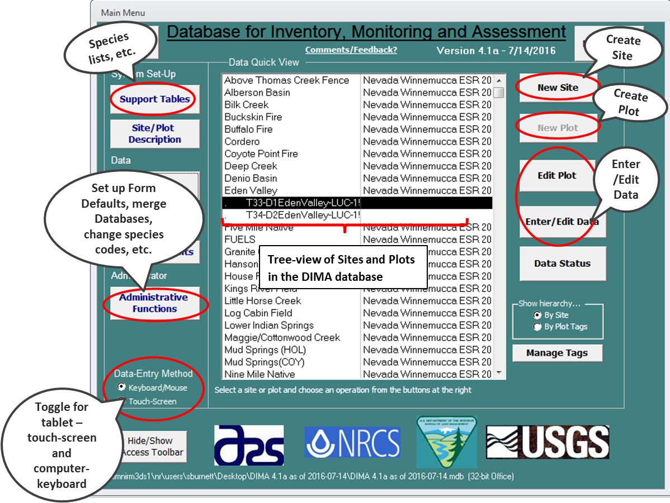

Set up DIMA for AIM

- Open DIMA database.
- Click on Administrative Functions button
- Select Database Content from the dropdown next to System Setup
- Click on Modify the Forms/Functions available in this copy… button.
- Enter the ‘9999’ Password when the prompt comes up.
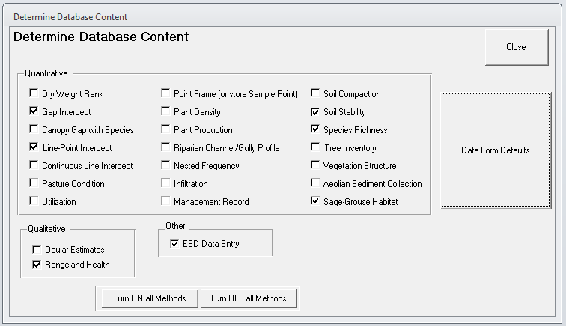
- In the Quantitative box, you can select the methods that will be collected in your DIMA, for AIM this will be Gap Intercept, Line-Point Intercept, Soil Stability, Species Richness, and if you will completing the HAF summary forms, Sage-Grouse Habitat. You can also choose Rangeland Health under Qualitative and ESD Data Entry if you will be doing either of those non-AIM methods.
- Click on Data Form Defaults.
- In the top of the form select Data collected is metric and Line Length: 25 m 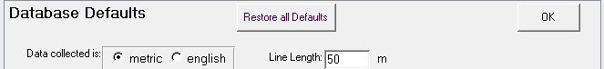
- Click on the Line-Point Intercept tab.
  - Mark the spacing interval to 50 cm and Starting Position to 0.5m. 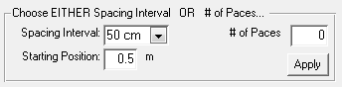
  - For Height Option, select every 5th and Height Units of cm. Select BLM AIM Herbaceous and Woody heights for the AIM height methods. To collect more height measurements also select Heights for Each layer (Top, Lower, and Soil). 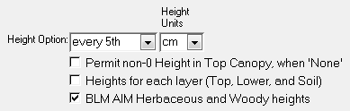
  - Click on the box beside Show Checkbox, in the text box, write ‘Standing Dead’. If you are collected Shrub Shape information click on the box beside the Show ShrubShape. 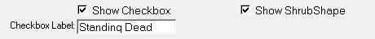
  - Select Include DS, WA, and GR as valid Lower slot choices. It is OK to have ‘None’ in Top Layer and a real Species Code in a Lower slot ONLY if one of these codes is above it.
- Click on the Gap Intercept tab.
  - For Minimum Gap, mark 20 cm.
  - For Data to be Collected, select Canopy Gap only. 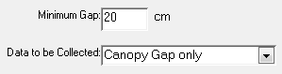
- Click on the Soil Stability tab.
  - Select Surface Only under This Sample Contains.
  - Select 15 seconds under Interval. 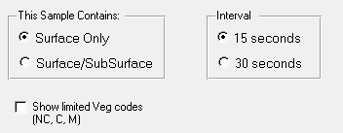
- Click on the Species Richness tab.
  - Select Sub-Plot Sizes are: Metric
  - Select Method: AIM 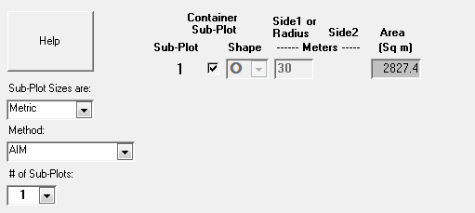
- Click Apply current settings to ALL plots… this will apply these defaults to every new plot created after you set these defaults. You shouldn’t have to set these for each plot; the defaults will automatically be populated.

