AIM-NAMF Implementation Roles and Responsibilities
AIM-NAMF implementation involves considerable effort, but with advanced planning and coordination, the workload is very manageable and can be shared by different members of the implementation team. The common members of an implementation team are State Leads, State Monitoring Coordinators, Project Leads, BLM NOC, the BLM/USU National Aquatic Monitoring Center (NAMC), and/or Field Crews. Role and responsibilities for each type of implementation team member are outlined on the AIM.landscapetoolbox.org website.
AIM-NAMF Roles and Responsibilities Table
Different models exist for dividing tasks among members of an AIM implementation team. Below we provide a template for assigning and communicating roles and responsibilities among members of an AIM-NAMF Implementation Team. This table needs to be completed by each project and/or state lead and shared with the other team members before the start of each field season. We encourage each lead to develop roles and responsibilities for each team member in a way that meets the project’s needs and capacity. An AIM-NAMF implementation team may involve team members not mentioned here; include additional team members in the table where appropriate.
We also provide three examples which illustrate how roles and responsibilities might differ among the AIM-NAMF Implementation Team. The example tables are identical in regards to the tasks to be completed throughout a year, but differ with respect to who is responsible for leading, assisting or participating in a given activity such as project design, crew hiring, data collection, data management, and reporting. The examples were developed to provide guidance to AIM-NAMF implementation teams and should not be viewed as exclusive.

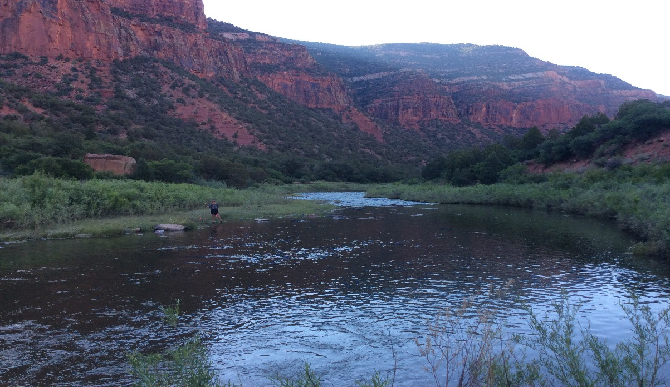

Instructions for Project and/or State Leads on how to fill out a roles and responsibilities table:
- Cells should be filled as Lead, Assist, Participate, or NA to indicate the role of the respective participant as it relates to the task.
- Where cells are already filled-out and bolded, the role or responsibility is fixed (i.e. cannot be changed) or not applicable (NA).
- When developing the table, remember that the examples provided below (1 – 3) are just examples and that responsibilities can be divided in any way seen fit, except when a task is fixed.

Table to be completed by Project and/or State Lead
Task | State Monitoring Coordinator | Project Lead | Crew Lead | Field Crew | NAMC
Project Design |  | Lead | NA | NA | Assist
Crew hiring |  |  |  | NA
Site Scouting |  |  |  | Participate
Hitch Planning |  |  |  | Participate
Crew Oversight/safety¹ |  |  |  | NA
Training |  |  |  | Participate | Lead
Vehicle/Gear Management
Data Collection/QA |  |  |  |  | Assist
Data Management/QC |  |  |  | Assist | Lead
Data Analysis/Reporting |  | Lead |  | NA | Assist
¹If Field Crews are hired through NAMC/USU, this model will require clear coordination with NAMC regarding crew work-load, management, and safety oversight.

Example 1: High Project Lead Involvement – No pre/post-field season assistance by crews. This model would work well when a Project Lead plans to be highly involved with the project and has time to dedicate to project management on a weekly basis. Approximate Project Lead time requirements are ~4-5 weeks (part-time) for project planning and field season prep (January – May) and ~5 hours/week for project oversight (June - September).
Task | State Monitoring Coordinator | Project Lead | Field Crew | NAMC
Project Design | Assist | Lead | - | Assist
Crew hiring | Assist | Lead | - | -
Site Scouting | - | Lead | Assist | -
Hitch Planning | - | Lead | Assist | -
Crew Oversight/safety¹ | - | Lead | Participate | -
Training | - | Participate | Participate | Lead
Vehicle/Gear Management | - | Lead | Participate | -
Data Collection/QA | - | Assist | Lead | Support
Data Management/QC | - | Assist | Assist | Lead
Data Analysis/Reporting | Assist | Lead | - | Assist
Example 2: Medium Project Lead Involvement – Crew Lead hired ~March through ~November to provide pre/post-season assistance and crew hiring assistance obtained from the State Monitoring Coordinator. This model is for a manager who wants to be intimately involved with the project, but does not have much time available for project management. Approximate Project Lead time requirements are ~2-3 weeks (part-time) for project planning (January – May) and ~2 hours/week for project oversight (June - September).
Task | State Monitoring Coordinator | Project Lead | Crew Lead | Field Crew | NAMC
Project Design | Assist | Lead | - | - | Assist
Crew hiring | Lead | Assist | - | - | Assist
Site Scouting | - | Assist | Lead | Participate | -
Hitch Planning | - | Assist | Lead | - | -
Crew Oversight/safety¹ | - | Lead | Assist | Participate | -
Training | - | Optional | Participate | Participate | Lead
Vehicle/Gear Management | - | Assist | Lead | Assist | -
Data Collection/QA | - | Assist | Lead | Assist | Support
Data Management/QC | - | Assist | Lead | Assist | Lead
Data Analysis/Reporting | Assist | Lead | Assist | - | Assist

Example 3: Low Project Lead involvement – Projects assisted by NAMC led project management. This model is best for a Project Lead who does not have an aquatic related program as a primary duty and/or is a new to AIM-NAMF implementation. Approximate Project Lead time requirements are ~2-3 weeks (part-time) for project planning (January – May) and <1 hour/week for project oversight (June - September).
 | State Monitoring Coordinator | Project Lead | Field Crew | NAMC
Project Design | Assist | Lead | - | Assist
Crew hiring | - | Assist | - | Lead
Site Scouting | - | Assist | Assist | Lead
Hitch Planning | - | - | Assist | Lead
Crew Oversight/safety¹ | - | Assist | Participate | Lead
Training | - | Participate | Participate | Lead
Vehicle/Gear Management | - | Lead | Assist | Assist
Data Collection/QA | - | Support | Lead | Assist
Data Management/QC | - | Assist | Assist | Lead
Data Analysis/Reporting | Assist | Lead | Assist | Assist
¹If Field Crews are hired through NAMC/USU, this model will require clear coordination of crew versus safety oversight with NAMC

