WHICH MODULE(S) SHOULD I USE
Data Analysis Modules: There are three files:
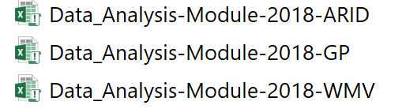
Each module is applicable to a plant region as defined in the 2014 National Wetlands Plant List, http://plants.usda.gov/core/wetlandSearch
For the National Wetlands Plant list, go to: http://wetland-plants.usace.army.mil/nwpl_static/v33/home/home.html
The following map depicts each of the three regions in the Western US: ARID, WESTERN MOUNTAINS/VALLEYS and COAST, and GREAT PLAINS.
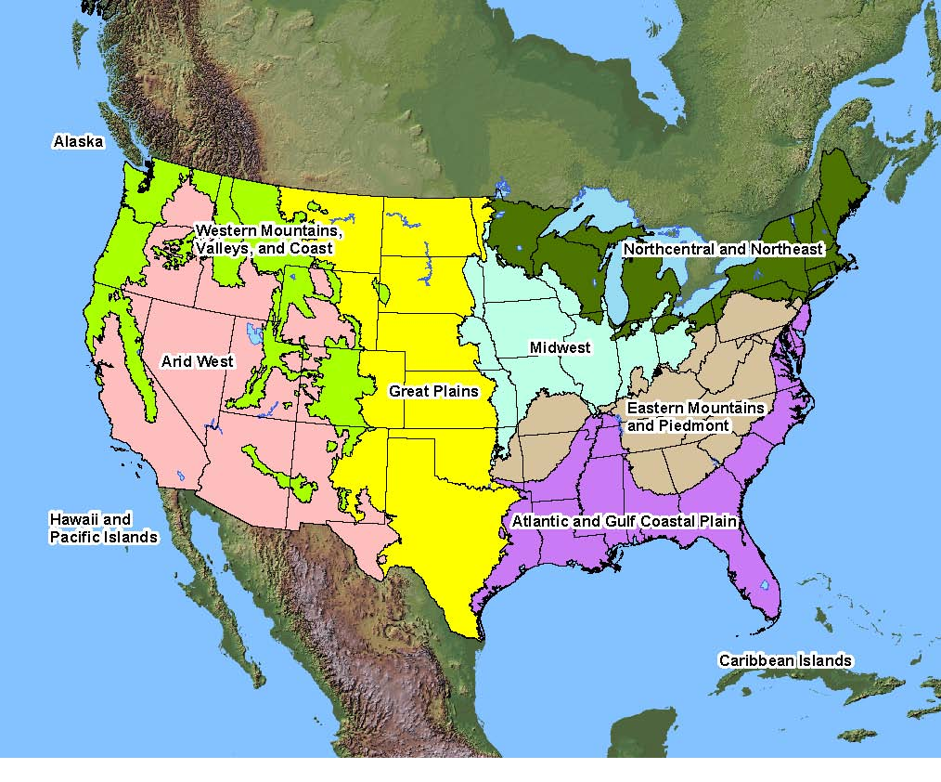

Data Entry Modules for Tablet: There are three modules applicable to the same regions as the Data Analysis Modules (ARID, GP, and WVM):
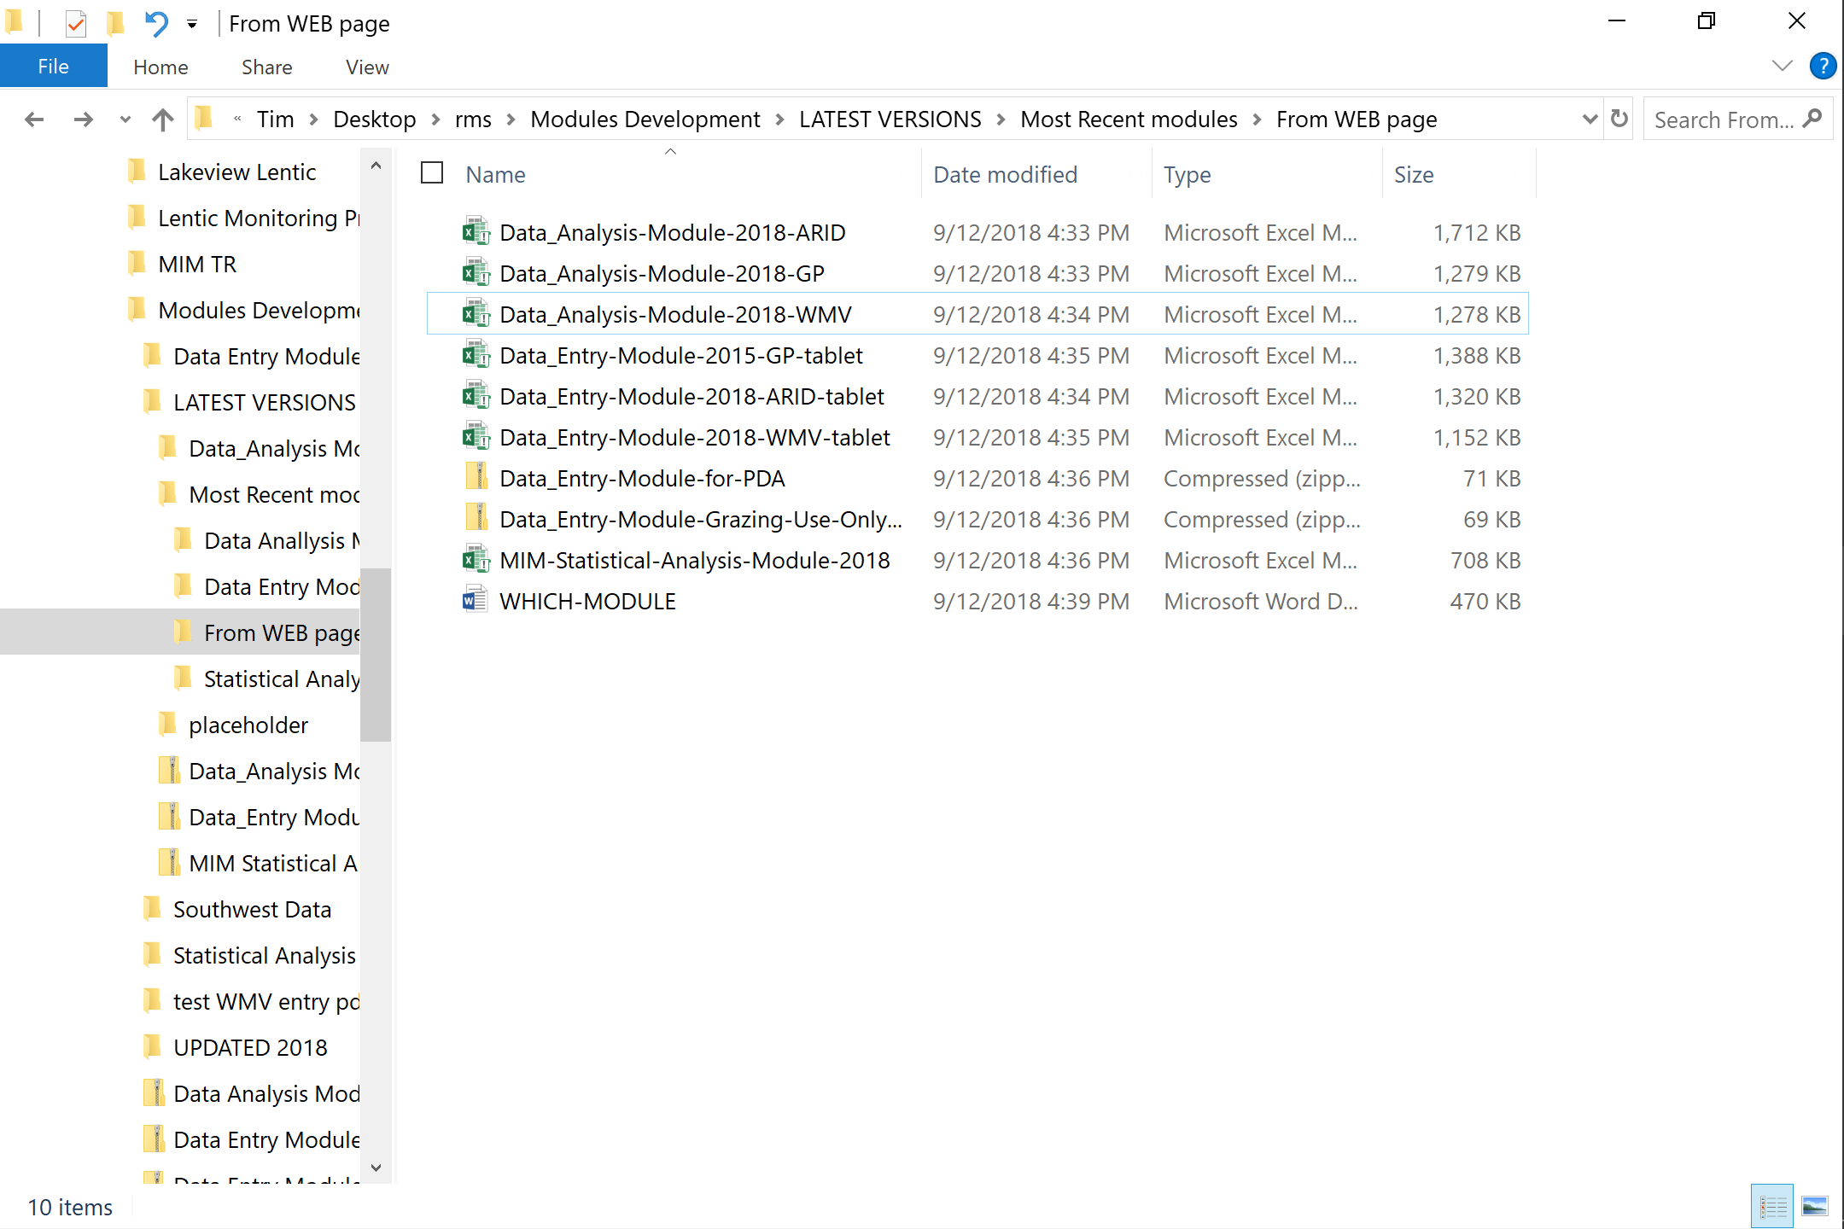
As with the Data Analysis Module, the user selects that module specific to his/her region. The tablet version is designed specifically for entering data using a device that supports “touch screen” input, but such input is not required. Most of the data entry cells will expand in size upon selection. Many more drop-down lists are provided to minimize typing, allowing the user to select items in the list. Tablets using this module preferably operate in a Windows environment using MS EXCEL, however data entry also works in EXCEL for IPAD, though with reduced functionality. Field data are transferred to the Data Analysis Module for analysis and metric summarization.

Data Entry Modules for Field PDAs (Personal data assistant): A PDA is a field computer designed to be used with field devices that support Windows Mobile with EXCEL Mobile or other device that does not support the full version of Windows and MS EXCEL. There are two files

These files are compressed. Simply extract them on the PC before transferring them to the PDA.
The Data Entry Module for PDA facilitates recording field data that is later transferred to the Data Analysis Module for analysis. The Data Entry Module Grazing Use is used specifically for entering short-term monitoring data, stubble height, bank alteration, bank stability, and woody use and specifically designed for the PDA.
See the Instructions for more details on the use and applicability of these modules.

